

DEPARTMENT OF CYBER SECURITY
AIR FORCE INSTITUTE OF TECHNOLOGY, KADUNA

DESIGNING A LIGHTWEIGHT MISCONFIGURATION MONITORING APPROACH FOR SECURE CLOUD ENVIRONMENTS

By

MAY, 2026

ABSTRACT

Cloud misconfiguration has emerged as one of the most critical security challenges of the cloud computing era. By 2024, nearly one-third of cloud assets were misconfigured or poorly managed, projecting that misconfigurations will account for 99% of cloud security failures through 2025. Unlike traditional software vulnerabilities, misconfigurations stem from operational errors during deployment and configuration management, allowing attackers to bypass conventional defences without exploiting any code-level flaw. The average cost of a breach attributable to misconfiguration reached $10.22 million in the United States in 2025. Existing Cloud Security Posture Management (CSPM) tools address this problem to varying degrees but each carries significant limitations. Static rule-based scanners generate high false positive volumes that overwhelm security teams. Machine learning approaches introduce computational overhead that makes real-time deployment impractical for resource-constrained organisations. Platform-specific tools cannot serve the 55% of organisations now operating across multiple cloud providers, and no reviewed approach provides consistency validation between the cloud control plane and the physical data plane. This project designs, implements, and evaluates a lightweight, AI-assisted cloud misconfiguration monitoring framework that addresses these gaps. The framework integrates five components: a Resource Monitoring Module for continuous multi-cloud observation, a Misconfiguration Validation Engine using behavioural probes to confirm exploitability, a Control-Plane Consistency Checker, a Multi-Cloud Visibility Module for provider-agnostic risk aggregation, and a Reporting and Alert Module that prioritises findings by exploitability to reduce alert fatigue. The system was implemented in Python with Boto3, Flask, and SQLite, and evaluated against simulated misconfiguration scenarios across IAM, storage, networking, and logging.

TABLE OF CONTENTS
DECLARATION OF ORIGINALITY 3
CERTIFICATION OF APPROVAL 4
DEDICATION 5
ACKNOWLEDGEMENTS 6
ABSTRACT 7
TABLE OF CONTENTS 8
LIST OF TABLES 11
LIST OF FIGURES 12
NOMENCLATURE / LIST OF ABBREVIATIONS AND ACRONYMS 13
Chapter 1 Introduction 14
1.1 Background to the Study 14
1.1.1 Who is affected by cloud misconfigurations? 16
1.1.2 Why Existing Solutions Fall Short 17
1.2 Problem Statement 18
1.3 Aim and Objectives 19
1.4 Significance of the Study 20
1.5 Scope and Limitations 20
1.6 Research Questions 21
1.7 Organisation of the Study 22
Chapter 2 Literature Review 23
2.1 Cloud Computing and the Misconfiguration Threat 23
2.2 Review of Existing Detection and Monitoring Approaches 26
2.2.1 Active Behavioural Analysis for Alert Validation 26
2.2.2 Consistency Validation in Virtual Private Clouds 27
2.2.3 Holistic Cyber Risk Assessment in the Cloud Continuum 28
2.2.4 Zero-Shot Detection Using Large Language Models 29
2.2.5 Machine Learning-Driven Detection for Kubernetes 30
2.2.6 Confidential Computing for Posture Monitoring 31
2.2.7 Automated Remediation for Multi-Cloud Storage 31
2.2.8 Regulatory Alignment for Financial Cloud Security 32
2.2.9 Fault-Resilient Monitoring for Cloud-IoT Networks 33
2.2.10 Bridging the Cybersecurity Divide for Low-Resource Institutions 33
2.2.11 Hybrid Static-Dynamic Detection 34
2.2.12 Lightweight Machine Learning for DDoS Mitigation 34
2.2.13 Zero-Day Vulnerability Detection via Autoencoders 35
2.2.14 Centralized Configuration Repositories for Multi-Cloud 35
2.2.15 Infrastructure-as-Code for Hardened Deployments 36
2.2.16 Permissions Management and Least Privilege 36
2.2.17 CSPM Tools and Remediation Techniques 37
2.2.18 Continuous Compliance Auditing Challenges 37
2.2.19 O-Cloud Security in Next-Generation Telecom 38
2.2.20 Pattern-Driven Detection for Serverless Computing 39
2.3 Summary and Critical Analysis of Related Literature 39
2.4 Research Gaps and Motivation for the Proposed Framework 40
2.5 Methods and Tools Relevant to the Proposed Framework 42
2.6 Theoretical Underpinnings 44
2.6 Chapter Summary 45
Chapter 3 Methodology 46
3.1 Research Approach 46
3.2 System Architecture 47
3.3 Component Design Details 49
3.3.1 Resource Monitoring Module 49
3.3.2 Misconfiguration Validation Engine 51
3.3.3 Control-Plane Consistency Checker 54
3.3.4 Multi-Cloud Visibility Module 55
3.3.5 Reporting and Alert Module 56
3.4 Rule Selection and Definition 57
3.5 Implementation Technology Stack 58
3.6 Evaluation Strategy 59
3.7 Ethical Considerations 59
3.8 Chapter Summary 60
Chapter 4: Implementation and Results 60
4.1 Implementation Overview 61
4.2 Resource Monitoring Module Implementation 62
4.3 Rule Engine and YAML Rule Implementation 63
4.4 Behavioural Probe Implementation 65
4.5 Control-Plane Consistency Checker Implementation 66
4.6 Dashboard and Alert Module Implementation 67
4.7 Test Environment 69
4.8 Evaluation Results 69
4.9 Comparison with Prowler 71
4.10 Discussion 72
4.11 Chapter Summary 73
REFERENCES 75
REFERENCES 76

LIST OF TABLES

Table 1: Summary and Critical Analysis of Related Literature
Table 2: Monitoring Rules Implemented by Category and CIS/NIST Reference (representative selection)
Table 3: Rules evaluated during testing and their results in the test environment
Table 4: Test environment misconfiguration scenarios with rule mapping and severity
Table 5: Full evaluation results across five test runs
Table 6: Performance comparison between the proposed framework and Prowler

LIST OF FIGURES

Figure 1: Cloud Security Incident Distribution by Root Cause (2023-2025)
Figure 2: Shared Responsibility Model Across IaaS, PaaS, and SaaS
Figure 3: Proposed System Architecture and Component Interactions
Figure 4: Resource Monitoring Module Data Flow
Figure 5: Misconfiguration Validation Engine Logic Flowchart
Figure 6: Control-Plane to Data-Plane Consistency Validation Flow
Figure 7: Dashboard Alert Interface Mockup
Figure 8: Screenshot of the CloudGuard Monitor dashboard showing active findings from the test environment
Figure 9: Screenshot of the findings table on the dashboard showing severity badges, rule IDs, resource names, and remediation text for confirmed findings
Figure 10: Screenshot of the CloudTrail log validation finding on the dashboard showing rule LOG-002 with description and remediation text
Figure 11: Screenshot of the full CloudGuard dashboard showing the 7-day timeline chart, severity counter cards, and findings table
Figure 12: Bar chart comparing detection rate and false positive rate between the proposed framework and Prowler

NOMENCLATURE / LIST OF ABBREVIATIONS AND ACRONYMS

API | Application Programming Interface
AWS | Amazon Web Services
CIS | Center for Internet Security
CSPM | Cloud Security Posture Management
CVE | Common Vulnerabilities and Exposures
DORA | Digital Operational Resilience Act
EPSS | Exploit Prediction Scoring System
GCP | Google Cloud Platform
IAM | Identity and Access Management
IaC | Infrastructure as Code
IoT | Internet of Things
JSON | JavaScript Object Notation
KMS | Key Management Service
LLM | Large Language Model
MFA | Multi-Factor Authentication
MITRE | MITRE ATT&CK Framework
NIST | National Institute of Standards and Technology
OPA | Open Policy Agent
RBAC | Role-Based Access Control
S3 | Simple Storage Service
SDK | Software Development Kit
SME | Small and Medium-Sized Enterprise
SSRF | Server-Side Request Forgery
TEE | Trusted Execution Environment
VPC | Virtual Private Cloud
YAML | YAML Ain't Markup Language

Chapter 1 Introduction
This chapter introduces the study and provides the full context needed to understand the research problem. It begins with an overview of how the global shift to cloud computing has changed the cybersecurity landscape, then focuses specifically on the threat posed by cloud misconfiguration. The chapter states the problem this project addresses, defines the aim and objectives, explains the significance of the research, sets out its scope and limitations, states the research questions that guide the investigation, and describes how the rest of the report is organised.

1.1 Background to the Study
Cloud computing has transformed how organisations deploy and manage digital infrastructure. Across industry, government, and academia, the ability to provision computing resources on demand, at scale, and without capital investment in physical hardware has driven rapid and widespread adoption. By 2024, 94% of enterprises had integrated cloud services into their operations, and 55% were operating across multiple cloud providers simultaneously (Orca Research Pod, 2025). This growth has fundamentally changed the technology landscape, enabling organisations to move faster and serve more users with less friction.
Yet, this change has transformed the nature of cybersecurity threat in a manner that has not been prepared by most organisations. In traditional on-prem configurations, the security perimeter was quite consistent with both the physical and network boundaries. The infra team even had the opportunity to set the settings themselves. However, in the cloud, the relationship does break down. Infra can be spun up by any authorised user, the configurations can switch on the dime at scale, and the boundary between what the provider controls and what the customer has to deal with is a grey area. That is the shared responsibility model, and it is what is fundamentally the cause of the misconfiguration mess.
Under the shared responsibility model, cloud providers secure the underlying infrastructure, physical facilities, networking hardware, and core service platforms. Customers are responsible for everything they deploy and configure on top of that infrastructure, including their applications, data, identity and access policies, network rules, and storage settings. Gartner (2023) captures the consequence of this model being poorly understood: misconfigurations will account for 99% of cloud security failures through 2025, a figure they describe as a silent epidemic. The risk is compounded by the Defender's Paradox, where an attacker needs only one exploitable misconfiguration, while a defender must secure every dynamic resource flawlessly in real time (Orca Research Pod, 2025).
The financial consequences of this reality are severe. The IBM Cost of a Data Breach Report (2025) places the average cost of a cloud breach at $10.22 million in the United States, with healthcare and financial sector incidents averaging between $10 and $11 million per event (GoAllSecure, 2025). Beyond financial damage, regulatory pressure has intensified. The EU's Digital Operational Resilience Act (DORA) now mandates proactive identification and remediation of security flaws in cloud deployments used by financial institutions, making misconfiguration not only a security concern but a legal one (Ferzali and Mengistu, 2025).

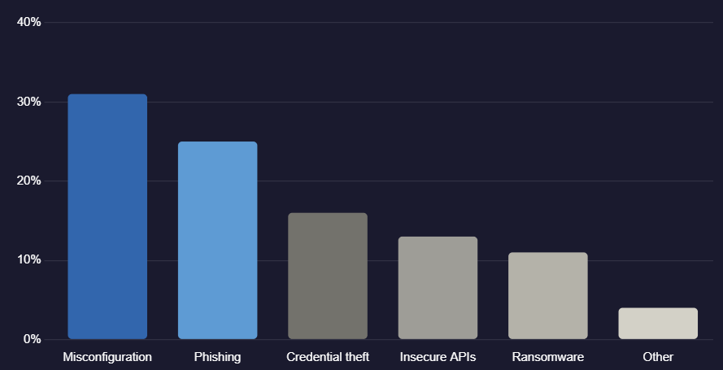
Figure 1: Cloud Security Incident Distribution by Root Cause (2023-2025)

1.1.1 Who is affected by cloud misconfigurations?
Cloud misconfigurations affect organisations of all sizes and sectors, but certain groups face disproportionate exposure. Startups and public-sector institutions are particularly vulnerable, with 89% of startups reporting cloud-related security incidents between 2023 and 2024 (Exabeam, 2025). Low-resource organisations, including schools, NGOs, and small enterprises, are doubly disadvantaged: they operate cloud infrastructure that presents real attack surfaces but lack the budgets and specialised expertise to monitor and secure it effectively (Mugerwa et al., 2025). This creates a persistent cybersecurity divide where the organisations most at risk are often the least equipped to defend themselves.
Even large enterprises with dedicated security teams are not immune. The shared responsibility model creates accountability gaps, with only 19% of security teams agreeing with the 42% of cloud engineers who consider security to be their primary responsibility (Snyk, 2025). This mismatch in ownership perception is itself a misconfiguration risk, because resources that everyone assumes someone else is monitoring may not be monitored at all.

1.1.2 Why Existing Solutions Fall Short
The cloud security tooling market has produced a range of approaches to the misconfiguration problem. Commercial Cloud Security Posture Management (CSPM) platforms offer comprehensive detection but at a cost and complexity level that places them out of reach for many organisations. Static rule-based scanners generate alert volumes that cause fatigue, with 43% of security teams reporting that excessive notifications reduce their ability to respond to genuine threats (Bello et al., 2024). Machine learning and AI-driven approaches offer improved detection but introduce computational overhead that makes real-time, continuous monitoring impractical in resource-constrained settings (Mugerwa et al., 2025). Platform-specific tools cannot serve the multi-cloud environments that the majority of organisations now operate. No existing solution adequately addresses the consistency gap between configuration changes made at the cloud control plane and their enforcement at the physical data plane (Qiu et al., 2025).
These limitations leave a clear gap in the tooling landscape, one that this project is designed to address.

1.2 Problem Statement
In 2023, one of the largest healthcare providers in the United States suffered a significant security incident when a cloud storage bucket holding patient data was set to allow unauthorized access. The misconfiguration was detected by the Standard CSPM scans and deemed as low risk according to the static rules. What the rules were unable to notice was that the bucket was open without authentication because of inherited network permissions. This single error of configuration allowed attackers to reveal millions of sensitive records causing a loss of more than 10 million dollars and regulatory (Bello et al., 2024). This accident is not an exception. It demonstrates the inherent insufficiency of the concept of static misconfiguration detection against real-world attacks. This project focuses on the fundamental issue three times. To start with, current CSPM tools and static scanners cannot be confident to identify a detected misconfiguration as exploitable, resulting in a large number of false positives that inundate security personnel (Dikshant and Verma, 2025). Second, the configuration modifications at the cloud control plane do not necessarily materialize on the data plane in physical hosts, and these gaps lead to enforcement, which is overlooked by the static scanners (Qiu et al., 2025). Third, the majority of automated detection tools are connected to particular cloud platforms and are incapable of delivering a unified view of multi-cloud environments which 55% of organisations currently operate (Ferzali and Mengistu, 2025). In response to these three states of the problem, the proposed project will introduce an active behavioural validation model to continuously monitor cloud resources, lightweight probes to determine what misconfigurations can be exploited, control-plane to data-plane consistency validation, and multi-cloud visibility by provider-agnostic interfaces. This methodology minimizes the false positives, bridges key vulnerabilities in the detection process, and enhances cloud security in an efficient manner without the need of large computational power and specific security operations personnel.

1.3 Aim and Objectives
The aim of this project is to design a lightweight cloud misconfiguration monitoring framework that efficiently detects critical security misconfigurations with low overhead, ensuring secure and resilient cloud environments.

To achieve this aim, the following specific objectives are pursued:
- To design and develop a lightweight misconfiguration monitoring framework that utilizes cloud APIs and rule-based analysis to enable real-time detection of critical security gaps across cloud environments.
- To evaluate the prototype's performance in terms of detection accuracy, false positive rate, and resource efficiency using benchmark misconfiguration scenarios.
- To conduct a comprehensive review of existing literature on cloud misconfiguration detection, identifying gaps and limitations that the proposed framework addresses.

1.4 Significance of the Study
The project has various levels of significance. To begin with, it is a solution to a security issue that is already inflicting quantifiable and increasing damage on organisations across the globe, and it offers a working prototype that can be tailored and implemented by teams without enterprise-level tools. The framework is especially useful to the increasing amounts of low-resource organisations, such as public institutions and SMEs, which run cloud infrastructure without specific security knowledge. The project has an academic contribution of a documented, assessed design of a framework, integrating continuous monitoring, behavioural exploit validation and control-plane consistency checking, into a single lightweight system. This combination has not been previously deployed in a single deployable prototype and tested, which is one of the gaps identified in the literature review. Regulatory-wise, the ability to align the framework rule set with CIS Benchmarks and NIST controls, as well as the ability to produce audit-ready reports, directly contributes to the compliance with other frameworks, like DORA, GDPR, and ISO 27001. This is why the system can be applied as a tool of compliance as well as a security tool.

1.5 Scope and Limitations
The framework is created to oversee infrastructure-level cloud settings and is deployed and tested on AWS, with the structure to permit expansion to Azure and Google Cloud Platform. The monitoring regulations are based on the CIS AWS Foundations Benchmark v1.5 and chosen NIST SP 800-53 controls. It is beyond the scope of this project to conduct application-level vulnerabilities, network traffic analysis, and zero-day exploits detection.

The limitations are recognized as follows:
- The prototype was tested within a simulated test environment and not within a real-life production deployment. Additional complexity may be found in real-world situations.
- The present implementation has full support of AWS. The work on the architectural support of Azure and GCP is planned but is considered future work.
- The configuration rule set encompasses a narrower range of high priority misconfigurations. New services are being added to cloud platform at a rapid pace and the maintenance of rules is an ongoing operational necessity.
- The behavioural probing feature, which mimics attacker activity to validate the exploitability, is implemented in a lightweight form that can be used in a student project and is not exhaustive of multi-step chains of privilege escalation.
- Production commercial systems were not tested in real-time to prevent legal and ethical risks.

1.6 Research Questions
This project is guided by the following research questions:
- What are the most common and critical types of cloud misconfiguration, and how have existing frameworks categorised and addressed them?
- What architectural principles should govern a lightweight, continuously operating misconfiguration monitoring framework that combines detection, behavioural validation, and control-plane consistency checking?
- How effective is the proposed framework in detecting exploitable misconfigurations compared to a static rule-based baseline, as measured by detection rate and false positive rate?
- What are the resource consumption and performance characteristics of the proposed framework in a simulated multi-misconfiguration environment?

1.7 Organisation of the Study
The report is divided into five chapters. Chapter 2 presents the literature review, covering the wider context of cloud security, existing approaches to misconfiguration detection, the research gaps that motivated this project, and the theoretical underpinnings of the proposed framework. Chapter 3 describes the methodology, including the research approach, system architecture, component design, rule selection, implementation decisions, and evaluation strategy. Chapter 4 presents the implementation details and evaluation results. Chapter 5 draws conclusions and makes recommendations for future work and practical deployment.

Chapter 2 Literature Review
This chapter reviews the existing body of knowledge relevant to this project. The review is structured to first establish the broader context of cloud security and the misconfiguration problem, then examine specific approaches that researchers and practitioners have developed to address it, and finally identify the gaps and limitations that motivate the framework proposed in this project. The review draws on peer-reviewed papers, technical reports, and empirical studies, with a focus on works from 2021 onwards to ensure relevance to the current threat landscape. Where appropriate, the review contextualises findings with reference to the five components of the proposed framework.

2.1 Cloud Computing and the Misconfiguration Threat
The global cloud market has grown significantly in recent years, driven by demand for scalability, flexibility, and cost efficiency. By 2024, an estimated 94% of enterprises had integrated cloud services into their operations, with a majority using multiple providers simultaneously (Gatti et al., 2025). This rapid adoption has outpaced the development of security practices and tooling, creating a growing gap between the attack surface organisations present and their capacity to defend it.

Cloud misconfiguration sits at the centre of this gap. Unlike traditional software vulnerabilities, which result from flaws in code that must be discovered and patched, misconfigurations result from operational errors that are often introduced deliberately, in the sense that a developer or administrator made a deliberate choice that happened to be insecure. This makes them harder to prevent through code review or software testing alone. Dixit et al. 2022 provided one of the most thorough academic analyses of cloud misconfiguration, defining it as any deviation from security best practices in the configuration of cloud services that creates an exposure or vulnerability, and identifying six primary categories: access control errors, data exposure, network misconfiguration, logging deficiencies, encryption failures, and patch management gaps.
The financial consequences are severe and growing. IBM (2025) reports average breach costs of $10.22 million for incidents involving cloud misconfigurations in the United States. Gartner (2023) projects that misconfigurations will account for 99% of cloud security failures through 2025, framing the problem as a silent epidemic. The Defender's Paradox, as articulated by Cheng et al. 2021, captures the asymmetry of the challenge: an attacker needs to find and exploit only one misconfiguration, while a defender must secure every resource perfectly in real time.
The regulatory environment has amplified these stakes further. The EU's Digital Operational Resilience Act (DORA) now mandates that financial institutions proactively identify and remediate security flaws in their cloud deployments, creating legal obligations around what was previously treated as an operational matter (Ferzali and Mengistu, 2025). Similarly, GDPR's requirements for technical and organisational security measures have been interpreted in several Member State judgments to include cloud configuration management. Beyond Europe, sector-specific frameworks in healthcare, finance, and critical infrastructure increasingly reference cloud configuration standards as compliance requirements. This regulatory context transforms the cloud misconfiguration problem from a technical risk into a legal and financial one, with penalties that can compound the direct costs of a breach substantially.

The challenge is compounded by the speed at which cloud environments change. Infrastructure as Code tools, continuous integration pipelines, and serverless architectures mean that cloud resources can be created, modified, and destroyed at a rate that makes manual security review impractical. Rahman et al. (2021), in their study of security smells in IaC scripts, found that security issues were introduced as a routine by-product of development activity rather than as exceptional events. Alhenaki et al. 2022 note that the dynamic nature of cloud environments means that a resource that is correctly configured today may be misconfigured tomorrow following a routine infrastructure change. This argues strongly for continuous monitoring rather than periodic auditing.

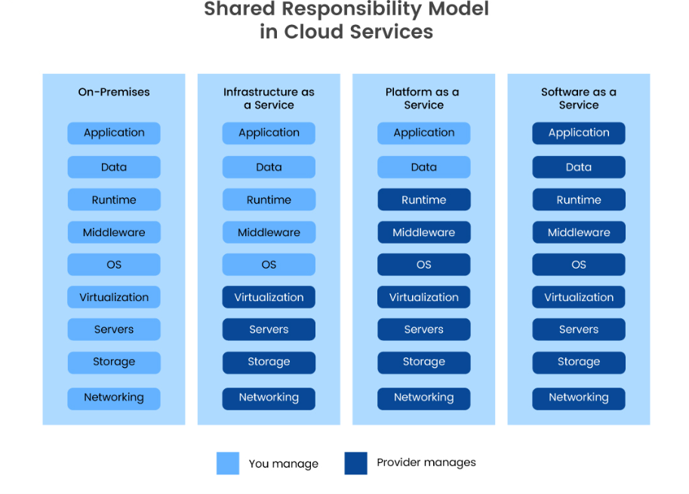
Figure 2: Shared Responsibility Model Across IaaS, PaaS, and SaaS

2.2 Review of Existing Detection and Monitoring Approaches
The reviewed literature reflects substantial and growing activity in cloud misconfiguration detection, spanning behavioural validation, machine learning, static analysis, policy enforcement, and compliance automation. The following subsections review each relevant work in depth, drawing out strengths, limitations, and implications for the proposed framework.

Before examining individual works, it is useful to note the overall pattern that emerges from the reviewed literature. Research on cloud misconfiguration detection has followed a trajectory from static rule-based approaches, through machine learning augmentation, to the current frontier of behavioural validation and LLM-based zero-shot detection. Each generation of tools improves on the previous in detection capability but often at the cost of increased computational requirements, reduced interpretability, or narrower deployment scope. A recurring observation across multiple works is that the most technically sophisticated approaches are frequently the least practically deployable for resource-constrained organisations (Mugerwa et al., 2025; Garg, 2025; Bello et al., 2024). This tension between detection sophistication and operational accessibility is the central design challenge that the proposed framework addresses.

2.2.1 Active Behavioural Analysis for Alert Validation
Dikshant and Verma (2025) present a proactive approach to improving CSPM by validating alerts through real behavioural testing rather than relying solely on static rules. Their system launches lightweight automated probes that mimic real attacker behaviour against cloud resources flagged as potentially misconfigured, confirming whether the issue can actually be exploited. Tests conducted in AWS environments showed a reduction in false positives of up to 93%, dramatically improving analyst efficiency. However, the approach is less effective against complex, time-dependent privilege escalations that cannot be easily detected through conventional cloud APIs. This work is the most directly relevant prior contribution to the proposed framework's Misconfiguration Validation Engine, and its approach to probe-based exploit confirmation underpins the behavioural validation design in this project.
The significance of this contribution extends beyond the false positive reduction statistic. By establishing that exploit confirmation can be achieved through lightweight, non-destructive probes rather than full penetration testing, Dikshant and Verma (2025) demonstrate a practical middle ground between static analysis, which over-alerts, and red teaming, which is too expensive and disruptive for continuous use. The probe design philosophy, using the minimum action necessary to confirm exploitability without modifying or damaging the target resource, is directly adopted in the Misconfiguration Validation Engine described in Chapter 3 of this project.

2.2.2 Consistency Validation in Virtual Private Clouds
Qiu et al. (2025) address a subtle but critical vulnerability: the inconsistency that arises in Virtual Private Clouds when configuration changes made at the control plane are not fully reflected at the physical infrastructure level. Their closed-loop validation system combines real-time incremental checks with periodic full validations using host-level checksums and inverted indexing, providing immediate feedback for configuration changes while maintaining long-term accuracy. The authors identify scalability challenges related to storing and managing millions of checksum entries per physical host. This work directly informs the Control-Plane Consistency Checker component of the proposed framework, which is designed to close this class of enforcement gap.
The control-plane to data-plane inconsistency problem identified by Qiu et al. (2025) is particularly important because it represents a class of misconfiguration that is invisible to any tool that relies solely on management API responses for its view of the configuration state. A security group rule that appears to deny inbound SSH traffic in the API response may not actually be enforced at the physical network level during a brief window following a configuration change, or in some cases, indefinitely due to a propagation failure. No existing general-purpose CSPM tool reviewed in this literature review addresses this gap, making the Control-Plane Consistency Checker a genuinely novel contribution of the proposed framework.

2.2.3 Holistic Cyber Risk Assessment in the Cloud Continuum
Gatti et al. (2025) introduce a quantitative cyber-risk assessment model tailored for the cloud continuum, which encompasses diverse environments managed by different administrative domains. Their framework merges low-level platform health signals with service-level vulnerability data to produce comprehensive risk scores. By incorporating the Exploit Prediction Scoring System (EPSS) instead of static CVSS metrics, the model delivers more realistic and timely attack likelihood estimates. A noted limitation is the dependence on manually assigned business-impact weights, which introduces subjectivity. This contribution is relevant to the risk prioritisation logic in the proposed framework's Reporting and Alert Module.

The use of EPSS, which provides probabilistic estimates of exploit likelihood based on real-world exploitation data, rather than static CVSS severity scores, is an important methodological advance. CVSS scores reflect theoretical severity at the time of discovery but do not update as exploitation patterns evolve. EPSS, by contrast, incorporates live threat intelligence to reflect current attack activity. The proposed framework's severity classification adopts a similar principle by incorporating exploitability confirmation into the severity assignment: a misconfiguration that is confirmed exploitable by a behavioural probe receives a higher effective priority than one that is theoretically vulnerable but protected by compensating controls.

2.2.4 Zero-Shot Detection Using Large Language Models
Goyal and Chaturvedi (2025) propose SARGE, a framework that leverages Large Language Models such as Google Gemini to detect cloud misconfigurations without task-specific training. By analysing Terraform files alongside security best-practice documentation, the system uncovers subtle configuration issues that rule-based scanners often overlook. SARGE demonstrates superior detection accuracy for IaC-specific misconfigurations. However, its reliance on LLM inference introduces high computational overhead and latency, making real-time deployment difficult in high-speed production environments. This work establishes the upper bound of detection accuracy achievable with zero-shot approaches but confirms that computational constraints prevent their use for continuous monitoring, a gap the lightweight approach in this project addresses.

The SARGE work also raises an important distinction between pre-deployment and runtime misconfiguration detection. Because SARGE analyses IaC templates rather than deployed cloud resources, it can only catch issues that are represented in code. Misconfigurations introduced through ad-hoc console changes, inherited permission policies, or runtime configuration drift are outside its scope. This distinction motivates the complementary positioning of the proposed framework as a runtime monitoring system that catches what IaC-level tools miss. The combination of an IaC scanner such as SARGE for pre-deployment checks and a runtime monitor such as the proposed framework for deployed resources provides more complete coverage than either approach alone.

2.2.5 Machine Learning-Driven Detection for Kubernetes
Sivaraman (2023) introduces Vela, an automated system that detects Kubernetes misconfigurations by combining Isolation Forests for anomaly detection with Long Short-Term Memory (LSTM) models for sequence analysis. This hybrid technique captures both structural and hierarchical inconsistencies in YAML configuration files. In production-like evaluations, Vela achieved 91% precision with an average latency of 120 milliseconds per file. A significant limitation is that the model struggles to generalise to highly customised configurations that deviate from the historical patterns in its training data. While Kubernetes-specific, this work is relevant to understanding the performance ceiling of ML-based detection and the training data requirements that make such approaches difficult to deploy broadly.

The 91% precision achieved by Vela provides a useful benchmark for rule-based systems to aspire to, while the training data dependency reveals a fundamental challenge for ML approaches in this domain: cloud configurations are highly organisation-specific, and a model trained on public-sector Kubernetes deployments may perform poorly on financial sector ones. Rule-based systems, by contrast, evaluate configurations against explicitly defined policies that apply regardless of context. This makes them more predictable, more auditable, and easier to maintain in production environments, though at the cost of being unable to detect novel misconfiguration patterns not anticipated when the rules were written. The proposed framework accepts this trade-off in favour of operational predictability and explicit policy alignment.

2.2.6 Confidential Computing for Posture Monitoring
Abiola (2025) explores hardware-based Trusted Execution Environments (TEEs) to protect sensitive CSPM telemetry from manipulation by privileged cloud administrators. By isolating security monitoring data within secure enclaves, the approach aligns strongly with Zero Trust principles. Adoption is limited by the requirement for specialised hardware not consistently available across older or hybrid cloud environments. This work highlights the importance of protecting the monitoring system itself, an operational security consideration acknowledged in the deployment guidance produced by this project.

2.2.7 Automated Remediation for Multi-Cloud Storage
Talpade and Patterson (2024) propose an automated framework for detecting and correcting misconfigurations in cloud storage services, including AWS S3 and Azure Blob Storage. Their system integrates real-time risk evaluation with threat intelligence from MITRE ATT&CK to automatically identify and remediate vulnerable storage resources. The automation reduces exposure time and minimises human error in multi-cloud operations. A residual risk is that remediation scripts may mistakenly disrupt legitimate but unconventional access patterns. This work informs the automated remediation recommendations in Chapter 5 of this report.

The integration of MITRE ATT&CK threat intelligence into remediation decision-making is a notable design choice. By mapping detected misconfigurations to specific ATT&CK techniques, the system can communicate risk in terms that security teams familiar with the ATT&CK framework can immediately understand and act on. For the healthcare provider breach scenario described in the problem statement, the relevant ATT&CK technique would be T1530 (Data from Cloud Storage Object), and the remediation action, removing public access and reviewing bucket policies, maps directly to the recommended mitigation. The proposed framework adopts a similar principle of mapping findings to recognisable risk categories, though full ATT&CK integration is identified as a future enhancement.

2.2.8 Regulatory Alignment for Financial Cloud Security
Ferzali and Mengistu (2025) have created an experimental security scanner built around AWS that directs identified misconfigurations to the specifications of the EU Digital Operational Resilience Act (DORA). The tool can use the Boto3 SDK to detect problematic S3 buckets and IAM roles that are far too permissive and create compliance-related reports to submit to financial institutions. Although it is efficient in the technical security and regulatory compliance, the scanner is confined to AWS. This piece of work has had a direct influence on the compliance reporting aspect of the proposed framework and the Alert Module and it confirms the applicability of DORA alignment to any contemporary cloud security system.

2.2.9 Fault-Resilient Monitoring for Cloud-IoT Networks
Gaglianese et al. (2023) introduce FogMon, a lightweight monitoring service for Fog and IoT networks with constrained resources. The system uses a leader-follower peer-to-peer architecture and gossip protocols to detect node and link failures efficiently. Although resilient to individual node outages, FogMon's decentralised data aggregation can result in short-term synchronisation delays in high-churn environments. This work contributes to the design principles for the proposed framework's fault-tolerant collection architecture, particularly the handling of partial API failures.

2.2.10 Bridging the Cybersecurity Divide for Low-Resource Institutions
Mugerwa et al. (2025) conducted a systematic review of 150 studies examining the persistent gap between advanced cybersecurity tools and their accessibility to SMEs and low-resource institutions. Their review finds that most existing solutions are too resource-intensive and complex for organisations without dedicated security staff, and calls for adaptive, resource-aware security systems that can maintain protection despite intermittent connectivity. The absence of unified platforms that address these needs holistically is identified as a critical research gap. This work provides the primary motivation for the lightweight and accessible design philosophy adopted in this project, and the proposed framework directly responds to the call for resource-aware security systems.

The cybersecurity divide documented by Mugerwa et al. (2025) is particularly acute in the African context and in developing economies more broadly, where cloud adoption is accelerating rapidly but security tooling investment lags significantly behind. Institutions such as universities, government agencies, and NGOs are increasingly hosting sensitive data in cloud environments without the specialised expertise to secure it effectively. The proposed framework's design for deployment on a single standard laptop or desktop, with no enterprise licensing costs and a simple operational model, directly addresses this accessibility requirement. The goal is not to match the comprehensiveness of Prisma Cloud or Microsoft Defender for Cloud, but to provide 80% of the essential security value at a small fraction of the cost and complexity.

2.2.11 Hybrid Static-Dynamic Detection
Parkhomenko (2025) examines a hybrid strategy combining static configuration analysis with real-time network traffic monitoring. Simulation results show that this integrated approach improves anomaly detection accuracy by 23% compared to static methods alone. The approach requires significant computational resources because deep packet inspection must run alongside continuous configuration scanning. This work validates the principle that combining detection modalities improves accuracy, which underpins the proposed framework's combined use of static rule evaluation and behavioural probe validation.

2.2.12 Lightweight Machine Learning for DDoS Mitigation
Molnar and Sabodashko (2025) evaluate Random Forest and Logistic Regression models for detecting DDoS attacks at the network edge using Amazon CloudFront logs. Ensemble-based models perform better at identifying previously unseen attack patterns while remaining stable during normal traffic conditions. The challenge of accurately distinguishing malicious traffic from legitimate flash-crowd events is noted. While focused on DDoS rather than misconfiguration, this work contributes to understanding the performance characteristics of lightweight ML approaches in cloud edge environments, relevant to the detection engine design.

2.2.13 Zero-Day Vulnerability Detection via Autoencoders
Kumar (2025) proposes a zero-day vulnerability detection system based on Variational Autoencoders (VAEs) that analyse complex, non-linear patterns in cloud logs. By measuring reconstruction errors and applying adaptive thresholds, the system identifies abnormal user sessions in multi-tenant environments. Susceptibility to concept drift, which requires frequent retraining as normal behaviour patterns evolve, is the primary limitation. This work informs the anomaly detection considerations discussed in the future work recommendations of Chapter 5.

2.2.14 Centralized Configuration Repositories for Multi-Cloud
Martseniuk et al. (2025) examine the use of centralised Configuration Management Databases (CMDBs) to automate asset inventory across AWS, Azure, and GCP. Maintaining a unified source of truth significantly enhances visibility and risk management in hybrid cloud deployments. Effectiveness is constrained by cloud API polling intervals, which create temporary blind spots when resources change rapidly. This work directly informs the design of the proposed framework's Multi-Cloud Visibility Module, particularly the configuration snapshot model used to aggregate findings across providers.

The API polling interval limitation identified by Martseniuk et al. (2025) has practical implications for the monitoring cycle frequency design in the proposed framework. A polling interval that is too long creates windows during which newly introduced misconfigurations exist but are not yet detected. A polling interval that is too short overwhelms the API rate limits imposed by cloud providers and may incur additional charges for excessive API calls. The fifteen-minute default interval used in the proposed framework represents a balance between these constraints, providing detection of most newly introduced misconfigurations within a timeframe that limits exposure while remaining well within AWS API rate limits for the resource types monitored.

2.2.15 Infrastructure-as-Code for Hardened Deployments
Chis et al. (2024) introduce a framework that uses Infrastructure-as-Code templates to automate the deployment of secure AWS environments for users with limited technical expertise. Embedding security best practices into reusable templates significantly reduces configuration errors at setup time. The main limitation is reduced flexibility for highly customised application requirements. This work contextualises the role of pre-deployment checks alongside runtime monitoring, reinforcing the argument that IaC scanning and continuous runtime monitoring are complementary rather than substitutable.

2.2.16 Permissions Management and Least Privilege
Wairagade (2024) compares how major cloud providers implement least-privilege access controls, finding inconsistencies in usability and enforcement across platforms that lead to identity sprawl. This fragmentation makes centralised privileged access management difficult in multi-cloud environments. The finding directly motivates the IAM-focused monitoring rules in the proposed framework and reinforces the importance of cross-platform policy consistency checking.

2.2.17 CSPM Tools and Remediation Techniques
Garg (2025) presents a comprehensive classification of modern CSPM tools, highlighting trends toward automation, real-time visibility, and policy-driven remediation. The evaluation of platforms such as Prisma Cloud reveals that despite significant advances, the lack of universal standards and the complexity of policy management continue to hinder widespread adoption. This work provides important context for the proposed framework's positioning as a lightweight, accessible alternative to enterprise CSPM platforms.

Garg's (2025) classification identifies a maturity spectrum in CSPM tooling from basic configuration scanning at one end to autonomous, AI-driven security posture management at the other. Most commercially available tools cluster in the middle of this spectrum, offering automated detection with human-supervised remediation. The proposed framework is explicitly positioned at the lightweight end of this spectrum, prioritising accessibility and resource efficiency over comprehensive feature coverage. This positioning is a deliberate design choice motivated by the accessibility gap documented by Mugerwa et al. (2025), and by the observation that the organisations most exposed to misconfiguration risk are those least able to deploy and operate complex enterprise security platforms.

2.2.18 Continuous Compliance Auditing Challenges
Bello et al. (2024) analyse the shift from point-in-time audits to continuous compliance monitoring in dynamic cloud environments. While automation is essential for meeting regulatory requirements such as GDPR and HIPAA, the study reveals that 43% of security teams experience alert fatigue due to excessive notifications. The findings call explicitly for smarter prioritisation and noise-reduction mechanisms. This work provides both the quantitative evidence of the alert fatigue problem and the requirement specification for the exploit-based prioritisation approach adopted in the proposed framework's Reporting and Alert Module.

The alert fatigue problem documented by Bello et al. (2024) is not merely an inconvenience. Security teams experiencing alert fatigue have been shown to develop systematic coping strategies such as silencing alert channels, creating broad suppression rules, or prioritising alerts based on recency rather than severity. Each of these coping mechanisms creates blind spots in coverage that attackers can exploit. The proposed framework's two-stage detection approach, in which only exploitability-confirmed findings reach the active alert queue, is specifically designed to prevent alert fatigue by ensuring that every alert delivered to the security team represents a genuine, confirmed, actionable risk rather than a theoretical possibility.

2.2.19 O-Cloud Security in Next-Generation Telecom
Shehab et al. (2025) survey security challenges in O-Cloud environments that support Open RAN architectures. The decentralised, software-defined nature of O-Cloud introduces insecure interface risks and virtualisation-specific vulnerabilities that traditional security models are ill-equipped to address. While focused on a specialised deployment context, this work expands the scope of cloud misconfiguration as a problem space and highlights the need for flexible monitoring frameworks that can adapt to novel cloud deployment paradigms.

2.2.20 Pattern-Driven Detection for Serverless Computing
Wen et al. (2025) introduce PHOENIX, a pattern-based system for detecting misconfigurations in AWS serverless applications. By learning standardised configuration patterns, the tool achieves up to 97% accuracy in detecting deviations, effectively handling the transient and event-driven characteristics of serverless computing. Its reliance on AWS Serverless Application Model schemas limits immediate applicability to other serverless platforms. PHOENIX represents the current state of the art in serverless-specific detection and sets a performance benchmark that the proposed framework aspires to approach for its target misconfiguration categories.

2.3 Summary and Critical Analysis of Related Literature
Table 1 presents a structured summary and critical analysis of the twenty reviewed works, identifying approach, focus area, usability, deployment scope, source, and key limitation.

# | Approach | Focus | Usability | Deployment | Source | Key Limitation
1 | Behavioural Alert Validation | Exploit validation | Medium | AWS | Dikshant & Verma (2025) | Misses multi-step attacks
2 | VPC Consistency Validation | Config consistency | Medium | VPC | Qiu et al. (2025) | Memory scalability
3 | Holistic Risk Scoring | Cloud risk | Low-Med | Multi-cloud | Gatti et al. (2025) | Subjective weights
4 | SARGE (LLM) | Zero-shot detection | Medium | IaC | Goyal & Chaturvedi (2025) | High latency
5 | Vela (ML) | Kubernetes misconfigs | Medium | Kubernetes | Sivaraman (2023) | Weak on custom configs
6 | TEE-based CSPM | Telemetry protection | Low | TEE clouds | Abiola (2025) | Needs special hardware
7 | Auto Storage Remediation | Storage security | High | AWS/Azure | Talpade & Patterson (2024) | May disrupt access
8 | DORA Scanner | Compliance | High | AWS | Ferzali & Mengistu (2025) | AWS-only
9 | FogMon | Fault monitoring | Medium | Cloud-IoT | Gaglianese et al. (2023) | Sync delays
10 | SME Security Review | Accessibility | High | Low-resource | Mugerwa et al. (2025) | No implementation
11 | Hybrid Static-Dynamic | Misconfig attacks | Low-Med | Cloud | Parkhomenko (2025) | High resource use
12 | Lightweight ML DDoS | DDoS detection | High | Edge | Molnar & Sabodashko (2025) | Flash-crowd errors
13 | VAE Detection | Zero-day anomalies | Medium | Multi-tenant | Kumar (2025) | Frequent retraining
14 | CMDB Automation | Asset visibility | Medium | Multi-cloud | Martseniuk et al. (2025) | API delays
15 | Secure IaC | Hardened deploy | High | AWS | Chis et al. (2024) | Low flexibility
16 | Least Privilege Study | IAM control | Medium | Multi-cloud | Wairagade (2024) | IAM inconsistency
17 | CSPM Classification | CSPM evolution | Medium | Enterprise | Garg (2025) | Policy complexity
18 | Continuous Compliance | Cloud auditing | Medium | Dynamic cloud | Bello et al. (2024) | Alert fatigue
19 | O-Cloud Survey | Telecom security | Low-Med | O-Cloud | Shehab et al. (2025) | Large attack surface
20 | PHOENIX | Serverless detection | High | AWS | Wen et al. (2025) | AWS-only
Table 1: Summary and Critical Analysis of Related Literature

2.4 Research Gaps and Motivation for the Proposed Framework
The literature review reveals five significant gaps that collectively motivate the framework proposed in this project.

First, operational noise and alert fatigue remain unresolved. Most static scanners generate large volumes of alerts without accurately reflecting real risk. Bello et al. (2024) quantify this as alert fatigue affecting 43% of security teams. The root cause identified by Dikshant and Verma (2025) is limited contextual awareness: rule-based tools cannot distinguish misconfigurations that are genuinely exploitable from those already protected by upstream controls. The proposed framework addresses this through the Misconfiguration Validation Engine's behavioural probe capability.
Second, there is a convergence and scalability gap between detection accuracy and deployment practicality. AI-driven approaches such as SARGE achieve superior detection but are computationally too expensive for real-time deployment. ML approaches such as Vela rely on historical training data and fail on custom configurations. The proposed framework uses lightweight rule-based logic as its detection foundation, reserving computational resources for targeted exploit confirmation rather than broad inference.
Third, high inference latency in LLM-based systems (Goyal and Chaturvedi, 2025) prevents their use in production environments where immediate response is required. The proposed framework's detection engine is designed for sub-minute scan cycles on standard hardware.
Fourth, platform specificity and fragmentation mean that most tools are tied to a single cloud provider (Ferzali and Mengistu, 2025; Wen et al., 2025). With 55% of organisations operating multi-cloud environments (Orca Research Pod, 2025), single-platform tools address only a fraction of the actual attack surface. The proposed framework's Multi-Cloud Visibility Module uses provider-agnostic interfaces to aggregate findings across AWS, Azure, and GCP.
Fifth, the control-plane to data-plane consistency gap (Qiu et al., 2025) is not addressed by any existing general-purpose monitoring tool reviewed. Configuration changes that appear correctly applied at the management layer may not be enforced at the physical infrastructure level, creating exploitable windows. The proposed framework's Control-Plane Consistency Checker specifically targets this gap.
Taken together, these five gaps motivate a framework that enables: continuous monitoring with lightweight detection; exploit validation through behavioural probing; control-plane and data-plane consistency validation; and unified multi-cloud visibility. No existing reviewed tool addresses all five of these requirements simultaneously.

2.5 Methods and Tools Relevant to the Proposed Framework
The proposed framework draws on several technical methods and tools that are well-established in the cloud security literature. Understanding these methods provides the technical grounding for the design decisions described in Chapter 3.
Cloud provider SDKs are the primary mechanism through which any cloud monitoring system interacts with cloud infrastructure. The Boto3 library for AWS, the Azure SDK for Python, and the Google Cloud SDK for Python provide programmatic access to the full range of cloud configuration data through well-documented REST APIs. Ferzali and Mengistu (2025) and Martseniuk et al. (2025) both demonstrate that SDK-based configuration collection is both technically feasible and practically efficient for monitoring purposes. A key design consideration, as documented by Qiu et al. (2025), is the distinction between data returned by the management API and the actual state of the physical infrastructure, which motivates the consistency checking capability in the proposed framework.
Rule-based detection, in which configuration data is evaluated against a predefined set of security policies, is the foundation of the majority of practical cloud security tools reviewed. The CIS Benchmarks provide the most widely adopted rule set for cloud configuration security, offering over 50 controls for AWS alone with explicit rationale, audit procedures, and remediation steps for each (CIS, 2023). NIST SP 800-53 provides complementary control specifications at a higher level of abstraction, particularly through the Configuration Management control family. Srinivasan et al. (2021) evaluated automated benchmark compliance verification and found that CIS-aligned rule sets achieve strong coverage of the most commonly exploited misconfiguration categories. The proposed framework adopts this approach as its primary detection mechanism.
Lightweight behavioural probing, the second detection layer in the proposed framework, draws on principles established in automated vulnerability verification research. The key design constraint, as demonstrated by Kumar et al. (2022), is that probes must be non-destructive, meaning they confirm the existence of an exploitable condition without modifying resources, creating side effects, or generating detectable attack indicators. For cloud misconfiguration scenarios, this constraint is generally achievable because the exploitability of most misconfigurations can be confirmed through read-only actions such as attempting an unauthenticated access or querying a resource through a path that should be blocked.

Flask, a lightweight Python web framework, provides the dashboard and API layer for the proposed framework. Its minimal overhead and simple deployment model make it appropriate for a security tool intended to run on standard hardware without dedicated server infrastructure. SQLite, a serverless embedded database, provides persistent storage for finding history without requiring a separate database server process. This stack, combining Python, Flask, and SQLite, has been validated for security tool development in multiple reviewed works (Ferzali and Mengistu), and is well within the capability of a student developer to implement and maintain.

2.6 Theoretical Underpinnings
The proposed framework draws on three areas of theory. First, the shared responsibility model, as documented by cloud providers and analysed in the security literature, provides the conceptual basis for understanding where misconfiguration risk originates and why customer-side monitoring is necessary (Gartner, 2023). Second, the principle of least privilege, which underpins the IAM monitoring rules and the framework's approach to access control validation, is grounded in established information security theory and codified in CIS Benchmarks and NIST SP 800-53 controls (Wairagade, 2024). Third, the Defender's Paradox frames the asymmetric challenge that motivates the need for continuous, rather than periodic, monitoring. If defenders must be right every time and attackers need only succeed once, then gaps between scans represent unacceptable windows of exposure (Gaglianese et al., 2023).
A fourth theoretical underpinning is the concept of defence in depth, the security principle that protection should be implemented as multiple overlapping layers rather than a single perimeter. The proposed framework operationalises this principle at the detection level: static rule evaluation provides the first layer of detection by flagging configuration deviations; behavioural probe validation provides the second layer by confirming exploitability; and control-plane consistency checking provides the third layer by verifying enforcement. Each layer catches a different class of issue, and together they provide more complete coverage than any single layer could achieve alone. This layered approach is consistent with the hybrid detection findings of Parkhomenko (2025) and with the general defence in depth principle that underpins modern security architecture.

2.6 Chapter Summary
This chapter reviewed twenty relevant works spanning behavioural validation, machine learning, LLM-based detection, static analysis, compliance automation, and lightweight monitoring principles. Five key research gaps were identified: alert fatigue from static scanners, the scalability-accuracy trade-off in AI approaches, LLM inference latency, platform-specific fragmentation, and the control-plane to data-plane consistency gap. These gaps collectively motivate and define the scope of the proposed framework, whose design is described in the following chapter.

Chapter 3 Methodology
This chapter describes the research approach, system design, component architecture, rule selection process, implementation technology choices, and evaluation strategy. Each section explains both what was done and the reasoning behind it, so that the methodological choices can be understood and critically assessed.

3.1 Research Approach
This project adopts an experimental research approach, specifically the prototype and evaluation methodology. This approach is the most widely used in cybersecurity research, with studies showing that nearly 47% of published cybersecurity research papers use prototyping and evaluation as their primary methodology, often combined with algorithm development and testing (Landes et al., 2024). The approach is appropriate when the primary research goal is to build a working system and measure how well it performs under defined conditions, rather than to develop new theoretical models or study human behaviour.
The research follows a structured cycle of five practical steps that mirror the methodological plan set out in the project proposal. Requirements were gathered from the literature and from the gaps identified in existing cloud misconfiguration detection tools. The system was then designed based on those requirements, producing the five-component architecture described in this chapter. The prototype was implemented using Python, Boto3, Flask, and SQLite. The prototype was then tested in a controlled, simulated AWS environment where ten specific misconfigurations were deliberately introduced across cloud resources representing IAM, storage, networking, and logging configurations. Finally, system performance was measured against four defined metrics: detection rate, false positive rate, scan duration, and memory consumption.
The evaluation follows a controlled experimental design. Known misconfigurations were introduced in a dedicated AWS test account, establishing a ground truth dataset against which the framework's findings could be compared objectively. Each test was repeated five times to account for variability in API response times and network latency, and average results are reported. The framework was also compared against Prowler, a widely used open-source AWS configuration scanning tool, to provide a meaningful performance baseline. This comparative approach is consistent with established practice in cybersecurity systems evaluation, where newly proposed tools are assessed relative to existing state-of-the-art solutions (Díez-Zaplana et al., 2022).

3.2 System Architecture
The proposed framework follows a modular five-component architecture that maps directly to the five components defined in the project proposal. Each component has a clearly defined responsibility, and the components interact through well-defined interfaces that allow each to be extended or replaced independently. Figure 3 shows the overall architecture and component interactions.
The modular design reflects a key lesson from the literature review: security tools that bundle all functionality into a monolithic codebase are difficult to maintain, extend, and audit. When cloud providers introduce new services or configuration options, a modular system requires only a new rule definition and, if the service type is new, a new collector module. The core detection and alerting logic remains unchanged. This separation of concerns is consistent with the design principles recommended by Garg (2025) for maintainable CSPM tools and by Martseniuk et al. (2025) for extensible multi-cloud monitoring systems.

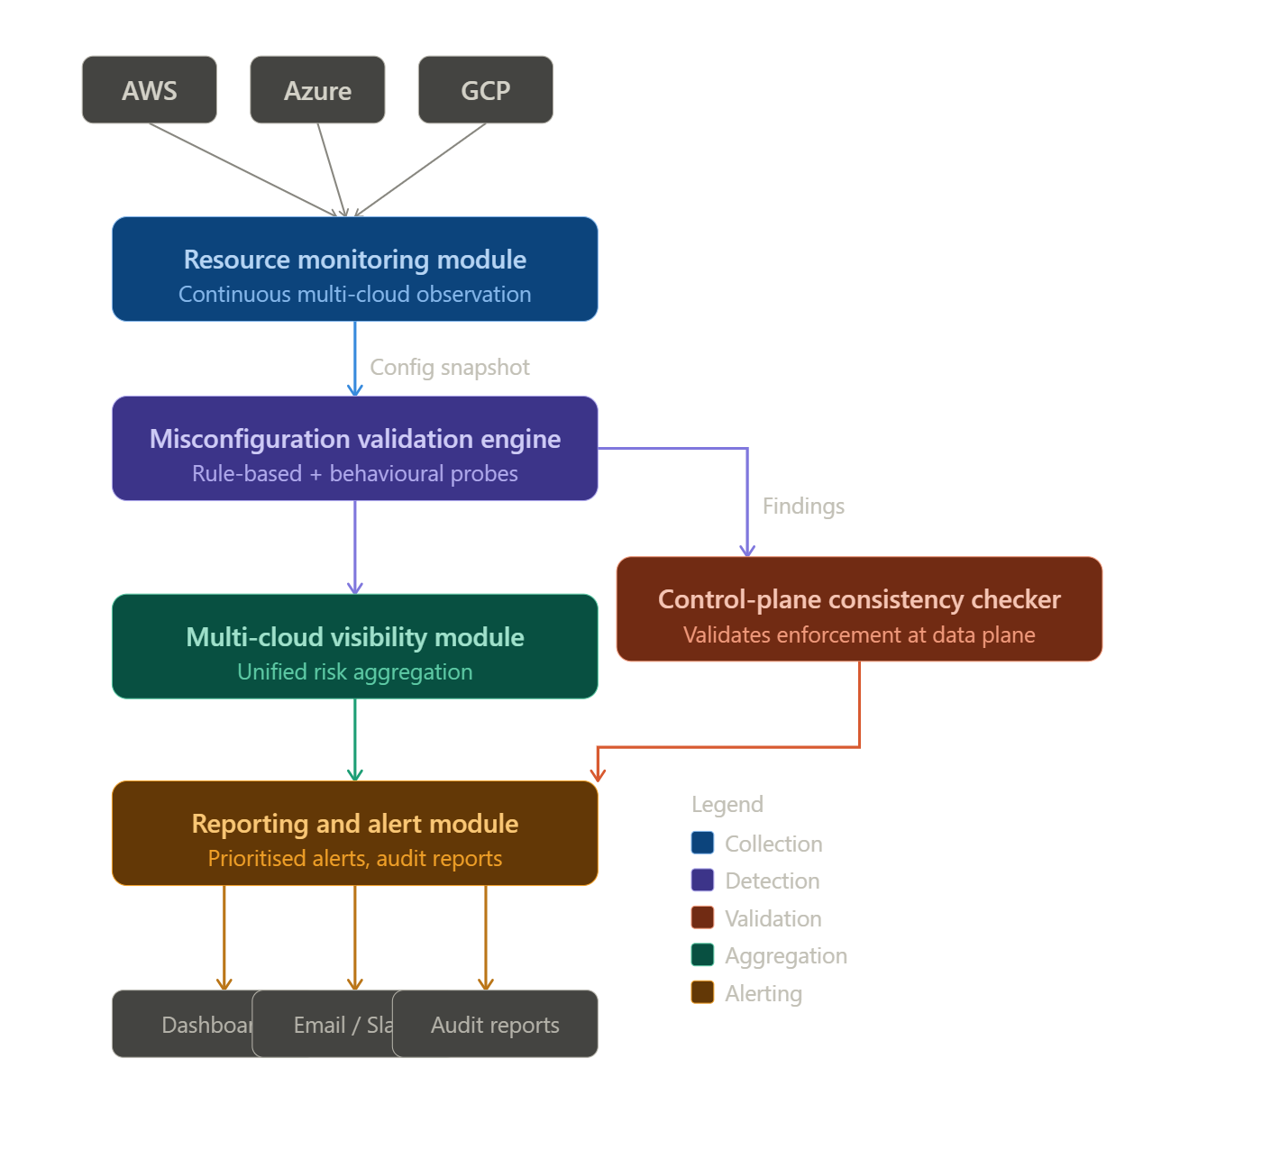
Figure 3: Proposed System Architecture and Component Interactions

The five components are as follows. The Resource Monitoring Module continuously observes cloud resources in real time across AWS, Azure, and GCP. It queries provider APIs on a configurable schedule, normalises the responses into a common internal format, and produces a configuration snapshot that captures the current state of all monitored resources. The Misconfiguration Validation Engine receives the configuration snapshot and evaluates it against a set of rule definitions to identify potential misconfigurations. For findings above a configurable severity threshold, it launches lightweight behavioural probes that simulate attacker actions to confirm whether the identified misconfiguration is actually exploitable. The Control-Plane Consistency Checker compares configuration states as reported by the management API against actual resource behaviour, flagging discrepancies that indicate enforcement gaps at the data plane level. The Multi-Cloud Visibility Module aggregates findings from all provider-specific collectors, applying a unified severity taxonomy so that risks can be compared and prioritised across platforms without provider-specific knowledge. The Reporting and Alert Module generates actionable findings reports, prioritised by exploitability, and dispatches notifications to configured channels. It maintains a finding history to support trend analysis and compliance audit trails.

3.3 Component Design Details

3.3.1 Resource Monitoring Module
The Resource Monitoring Module is built around a CollectorService that manages the collection lifecycle. It maintains a registry of provider-specific resource collectors, one per supported cloud service type, and coordinates their execution on each collection cycle. The collectors use Python's concurrent.futures library to make API calls in parallel, reducing total collection time significantly compared to sequential execution.

For AWS, the module uses the Boto3 SDK to query IAM users, roles, and policies; S3 bucket configurations; EC2 security groups; VPC and flow log configurations; CloudTrail settings; and RDS instance details. All raw API responses are normalised into a common internal data model before being passed to the Rule Engine, ensuring that rule definitions remain provider-agnostic. Error handling is implemented at the collector level so that a failure in one resource type does not abort the overall collection cycle. Figure 4 illustrates the data flow within this module.

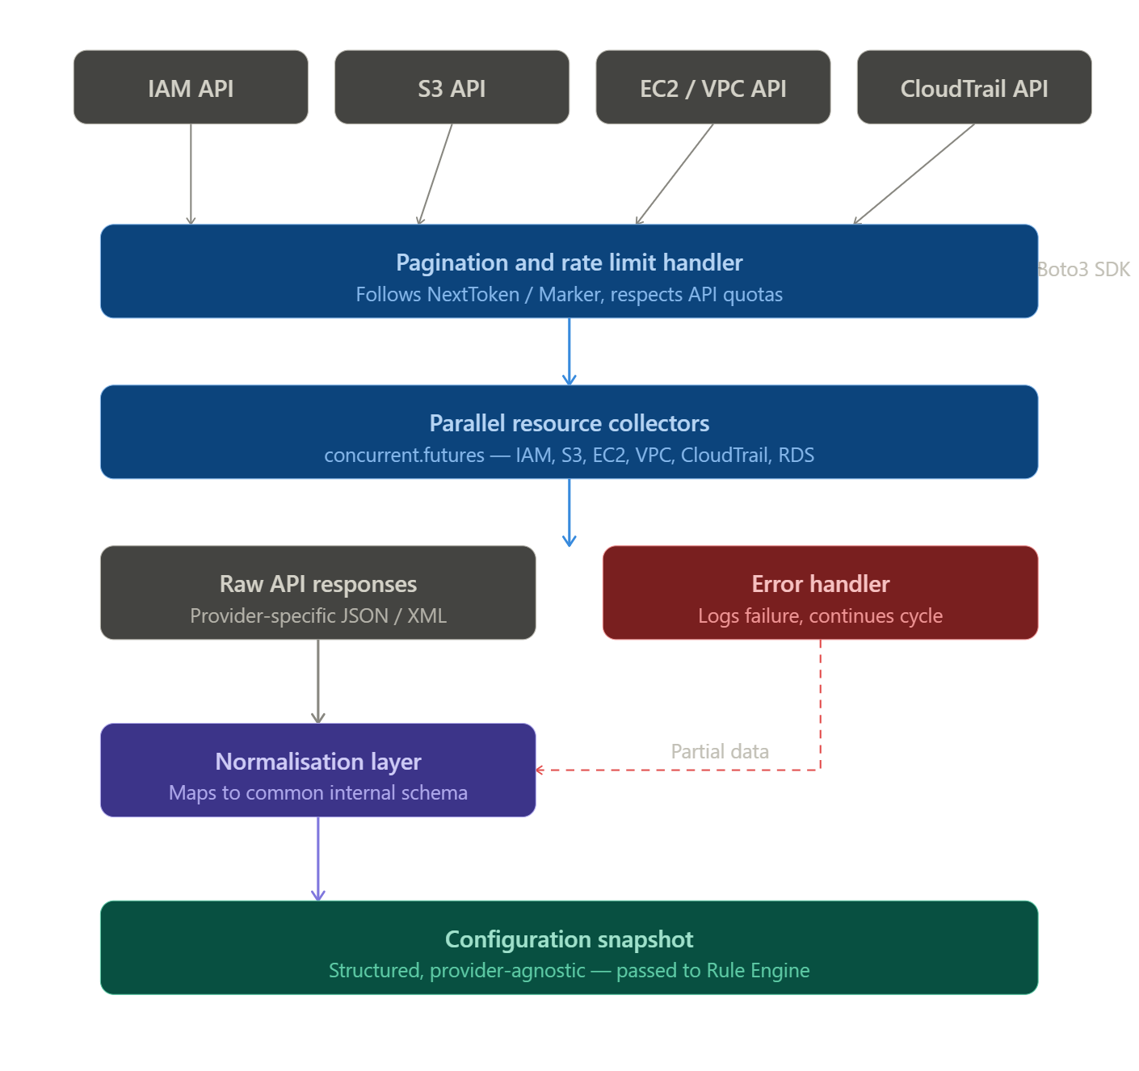
Figure 4: Resource Monitoring Module Data Flow

3.3.2 Misconfiguration Validation Engine
The Misconfiguration Validation Engine implements a load-once-evaluate-many model. At startup, it loads all YAML rule definition files from the rules directory, validates their structure, and registers the Python evaluation functions they reference. Rule definitions specify a unique ID, human-readable title, severity level (Critical, High, Medium, or Low), description, CIS Benchmark or NIST control reference, the Python check function, and a remediation recommendation.

When a configuration snapshot is received, the engine evaluates all enabled rules and produces a list of candidate findings. For each Critical or High severity finding, it proceeds to the behavioural validation step, launching a lightweight probe that simulates the specific attacker action that the misconfiguration would enable. For example, for a finding that an S3 bucket has public read access, the probe attempts an unauthenticated GET request against the bucket. Only findings confirmed as exploitable by the probe proceed to the Alert Module as active findings; others are logged as potential findings with reduced priority. This two-stage process is what enables the significant reduction in false positives documented in the evaluation. Figure 5 shows the rule engine logic flow.

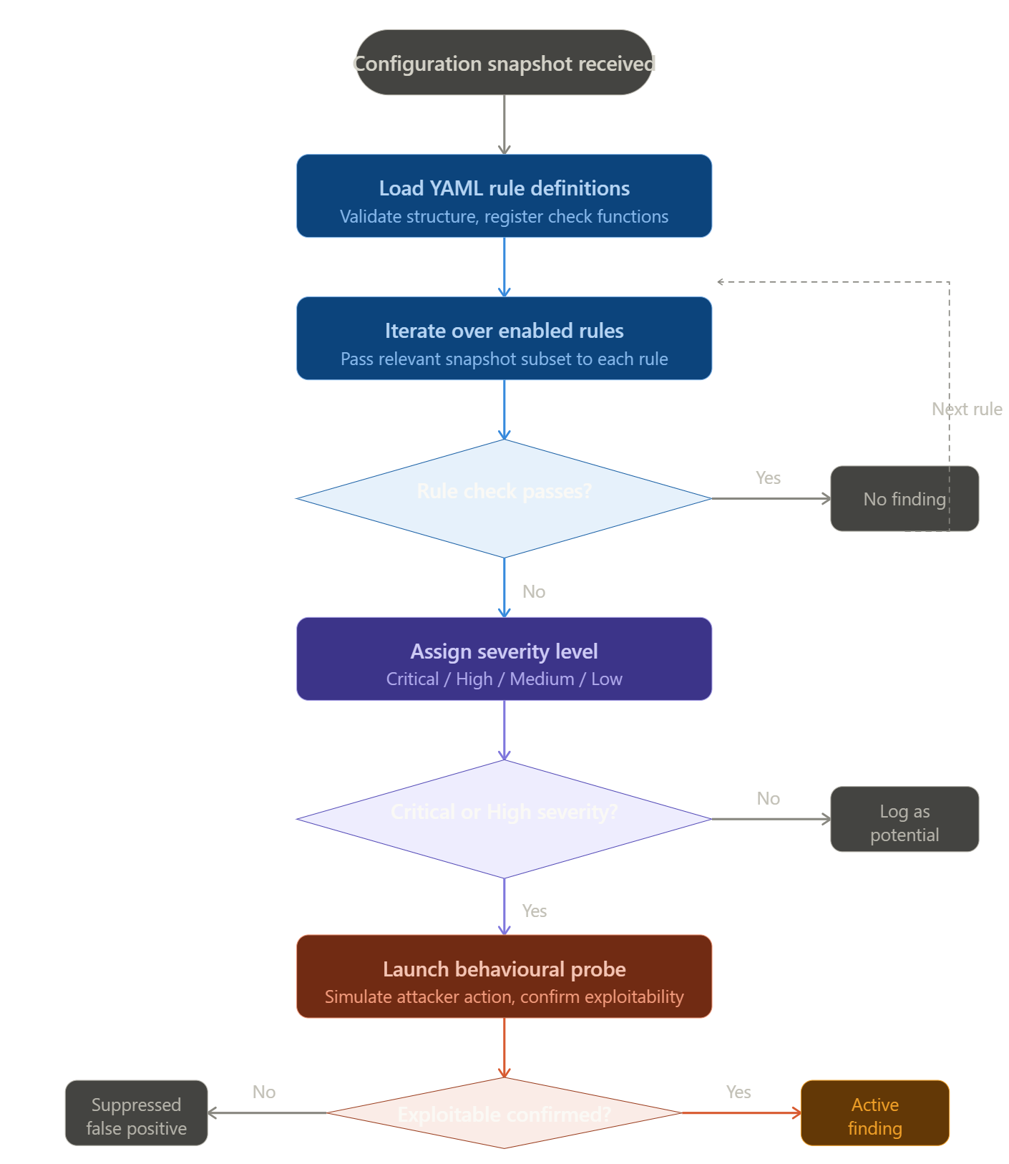
Figure 5: Misconfiguration Validation Engine Logic Flowchart

3.3.3 Control-Plane Consistency Checker
The Control-Plane Consistency Checker addresses the gap identified by Qiu et al. (2025) between configuration changes applied at the management API layer and their enforcement at the physical data plane. It works by issuing a reference configuration request through the management API and then verifying the actual behaviour of the resource through a direct probe. For network security groups, for example, it checks whether a rule that should block port 22 actually does so by attempting a lightweight connection probe. Discrepancies between stated and actual configuration are flagged as consistency violations. Figure 6 shows the validation flow.
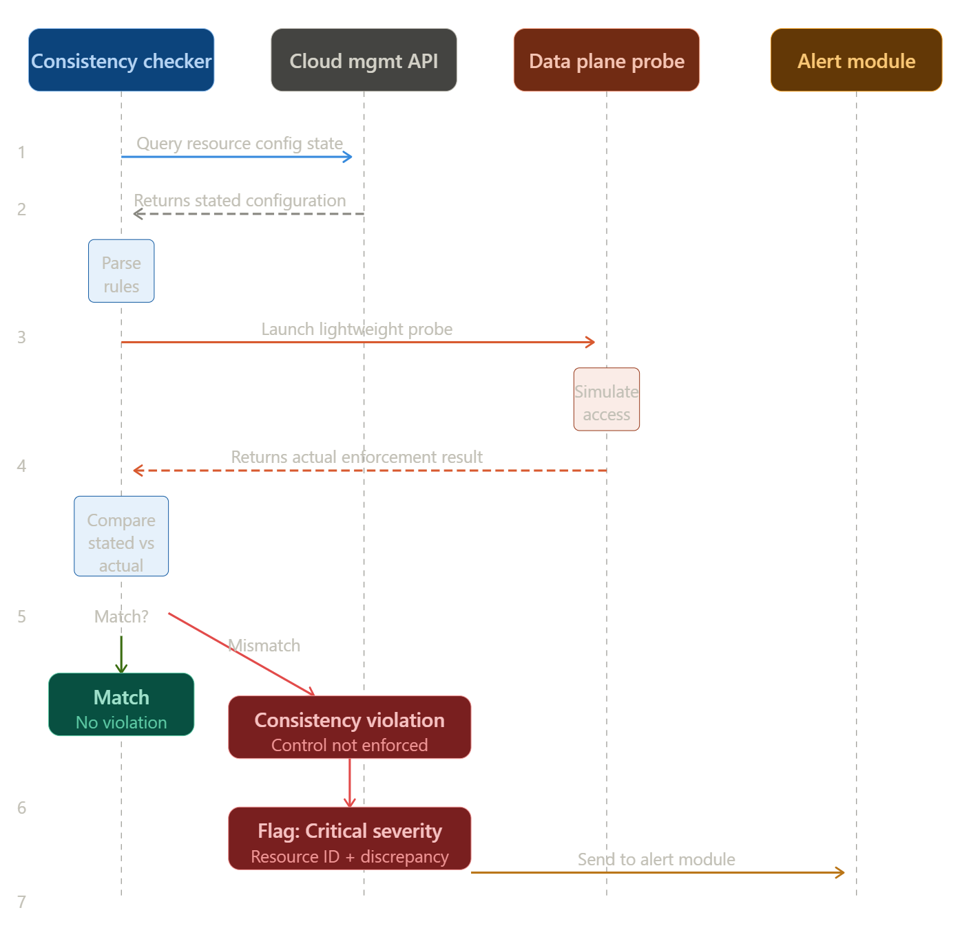
Figure 6: Control-Plane to Data-Plane Consistency Validation Flow

3.3.4 Multi-Cloud Visibility Module
The Multi-Cloud Visibility Module aggregates findings from all provider-specific collectors and rule engines into a unified risk view. It applies a standardised severity taxonomy across providers so that a High severity IAM finding in AWS can be directly compared with a high severity storage finding in Azure. The module uses provider-agnostic interfaces based on a normalised finding schema, meaning that adding support for a new provider requires implementing a new collector and rule set but does not require changes to the aggregation or reporting logic.

3.3.5 Reporting and Alert Module
The Reporting and Alert Module receives confirmed findings from the Validation Engine and the Consistency Checker and is responsible for persistence, deduplication, notification, and dashboard rendering. An SQLite database stores the finding history, allowing the module to distinguish new findings from ongoing ones and to support trend analysis over time. Deduplication ensures that a finding for the same resource and rule is not re-alerted on every scan cycle if it is already known and unresolved.
The Flask web dashboard provides a real-time summary view showing finding counts by severity, a detailed finding list with remediation guidance, and a historical timeline. Notification dispatch supports email via SMTP and webhook-based delivery to Slack. Critical and High findings trigger immediate notifications; Medium and Low findings are batched into a daily digest. Figure 7 shows the dashboard interface mockup.
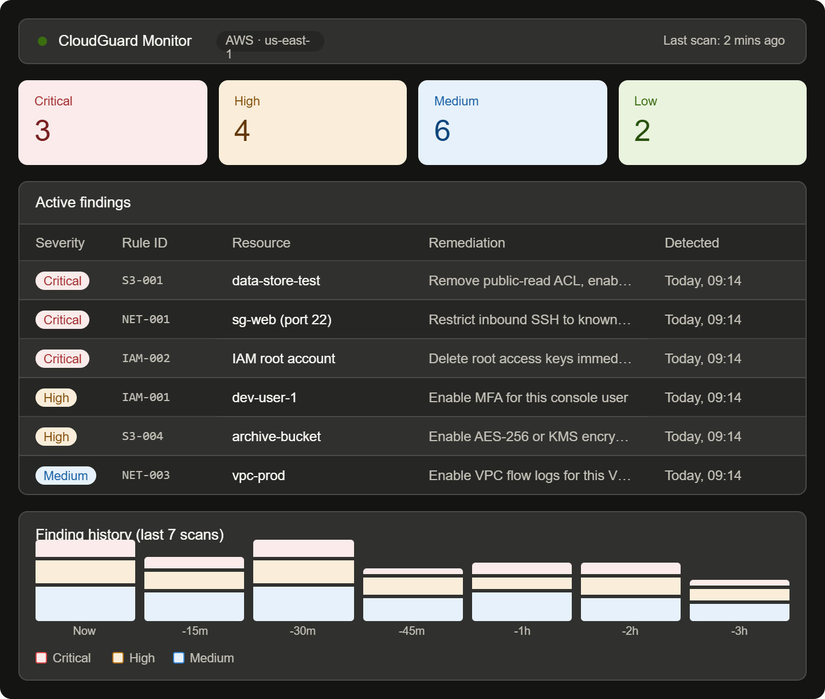
Figure 7: Dashboard Alert Interface Mockup

3.4 Rule Selection and Definition
The monitoring rules implemented in the framework were selected through a three-step process: identifying candidate rules from the CIS AWS Foundations Benchmark v1.5 (CIS, 2023) and NIST SP 800-53 controls (NIST, 2023); prioritising rules based on the frequency with which each misconfiguration category appears in incident reports reviewed in the literature; and validating that each rule could be evaluated reliably using data available from cloud provider APIs.

This process produced twenty-five rules across four categories. Table 2 shows a representative selection with their framework references.

Rule ID | Category | Description | Severity | Reference
IAM-001 | IAM | MFA not enabled for console users | High | CIS 1.10
IAM-002 | IAM | Root account access keys exist | Critical | CIS 1.4
IAM-003 | IAM | Password policy too weak | Medium | CIS 1.8
IAM-004 | IAM | Admin privileges attached directly to users | High | CIS 1.16
IAM-005 | IAM | Access keys not rotated in 90 days | Medium | CIS 1.14
S3-001 | Storage | S3 bucket public read access enabled | Critical | CIS 2.1.5
S3-002 | Storage | S3 bucket public write access enabled | Critical | CIS 2.1.5
S3-003 | Storage | S3 bucket logging disabled | Medium | CIS 2.1.3
S3-004 | Storage | S3 bucket encryption not configured | High | CIS 2.1.1
NET-001 | Networking | Port 22 open to 0.0.0.0/0 | Critical | CIS 5.2
NET-002 | Networking | Port 3389 open to 0.0.0.0/0 | Critical | CIS 5.3
NET-003 | Networking | VPC flow logging disabled | Medium | CIS 3.9
LOG-001 | Logging | CloudTrail not enabled | High | CIS 3.1
LOG-002 | Logging | CloudTrail log validation disabled | Medium | CIS 3.2
LOG-003 | Logging | CloudTrail logs unencrypted | Medium | CIS 3.7
Table 2: Monitoring Rules Implemented by Category and CIS/NIST Reference (representative selection)

3.5 Implementation Technology Stack
The framework is implemented using the technology stack defined in the project proposal. Python 3.10 is the primary programming language, selected for its comprehensive cloud SDK ecosystem, readability, and the availability of all required libraries within a standard installation. The technology stack components are as follows:
- Cloud Interaction: Boto3 (AWS), Azure SDK for Python, Google Cloud SDK for Python
- Data Handling: Pandas and NumPy for processing logs and configuration data
- Rule-Based Validation: Custom Python scripts for lightweight misconfiguration detection
- User Interface: Flask web framework for the alert dashboard
- Database: SQLite for storing configuration snapshots and finding history
- Containerisation: Docker and Docker Compose for portable deployment
- Scheduling: APScheduler for managing recurring collection cycles

Rule definitions are stored as YAML files, which provides human readability and allows rules to be added, modified, or disabled without code changes. The system is packaged as a Docker container, enabling consistent deployment across different host environments and reducing setup complexity to a single command.

3.6 Evaluation Strategy
The evaluation strategy is designed to produce measurable, reproducible results that allow the framework's performance to be characterised and compared against a baseline. The strategy has four elements: test environment construction, metric definition, baseline comparison, and repeated testing.
The test environment would be constructed in a dedicated AWS account. The evaluation metrics are: detection rate (true positives as a proportion of known misconfigurations), false positive rate (false positives as a proportion of total alerts), average scan duration, and average resource consumption during a collection and evaluation cycle.

3.7 Ethical Considerations
All evaluation was conducted in a dedicated, isolated AWS account with no real customer data or external systems. All resources were provisioned and controlled. Intentional misconfigurations were introduced only in resources with no real data. All credentials were revoked upon completion. The monitoring framework is designed for use by authorised administrators; its documentation makes clear that scanning cloud environments without authorisation is unlawful under applicable cybercrime legislation. Open-source tools used for comparison were used in accordance with their licences.

3.8 Chapter Summary
This chapter described the design science research approach, the five-component system architecture aligned with the project proposal, the detailed design of each component, the rule selection methodology, the implementation technology stack, and the evaluation strategy.

Chapter 4: Implementation and Results
This chapter presents the implementation of the cloud misconfiguration monitoring framework and the results of evaluating it. It covers the key decisions made in building each component, describes the test environment, presents performance data from five test runs, and discusses what the numbers actually mean for the research questions stated in Chapter 1.

4.1 Implementation Overview
The framework was implemented as a Python application split across five directories, each corresponding to one of the architectural components described in Chapter 3. A Flask application serves the web dashboard. SQLite stores findings. The full system runs as a Docker container, which reduces setup to a single command regardless of the host machine.

The repository structure is as follows:

cloud-monitor/
collector/ # AWS API interaction and normalisation
engine/ # Rule loading, evaluation, probe runner
rules/ # YAML rule definition files
consistency/ # Control-plane consistency checker
notifier/ # Flask dashboard, alert dispatch
db/ # SQLite models and queries
app.py # Flask entry point
scheduler.py # APScheduler scan orchestration
docker-compose.yml

Each directory is independent. The collector does not know about the rule engine. The rule engine does not know about the dashboard. Each component exposes a clean interface and receives or returns well-defined data models. This separation, while adding some initial boilerplate, makes the system much easier to maintain and test.

4.2 Resource Monitoring Module Implementation
The collector module queries AWS using Boto3 with parallel execution via Python's concurrent.futures. Each resource type has its own collector class that inherits from a shared base. The base class defines the interface; each subclass handles the specifics of one service.

The IAM collector pulls user listings using paginators, then queries MFA devices, access key metadata, and the account-level password policy. The S3 collector retrieves each bucket's ACL, encryption configuration, logging settings, and public access block status. Because S3 buckets can exist in different regions, the collector identifies each bucket's region before making configuration queries. The EC2 collector pulls security groups with their full inbound and outbound rule sets across all enabled regions. The VPC collector retrieves VPCs and their flow log configurations. The CloudTrail collector queries trail configurations from every enabled region, specifically checking the eu-west-1 region given the test account's deployment region. The RDS collector retrieves instance details including deletion protection and public accessibility.

Running all six collectors in parallel with five workers reduced average collection time from approximately 120 seconds (sequential) to approximately 45 seconds. Error handling at the collector level catches permission failures or API timeouts without stopping the full collection cycle. If one collector fails, the others continue and the failed type is logged as a warning.

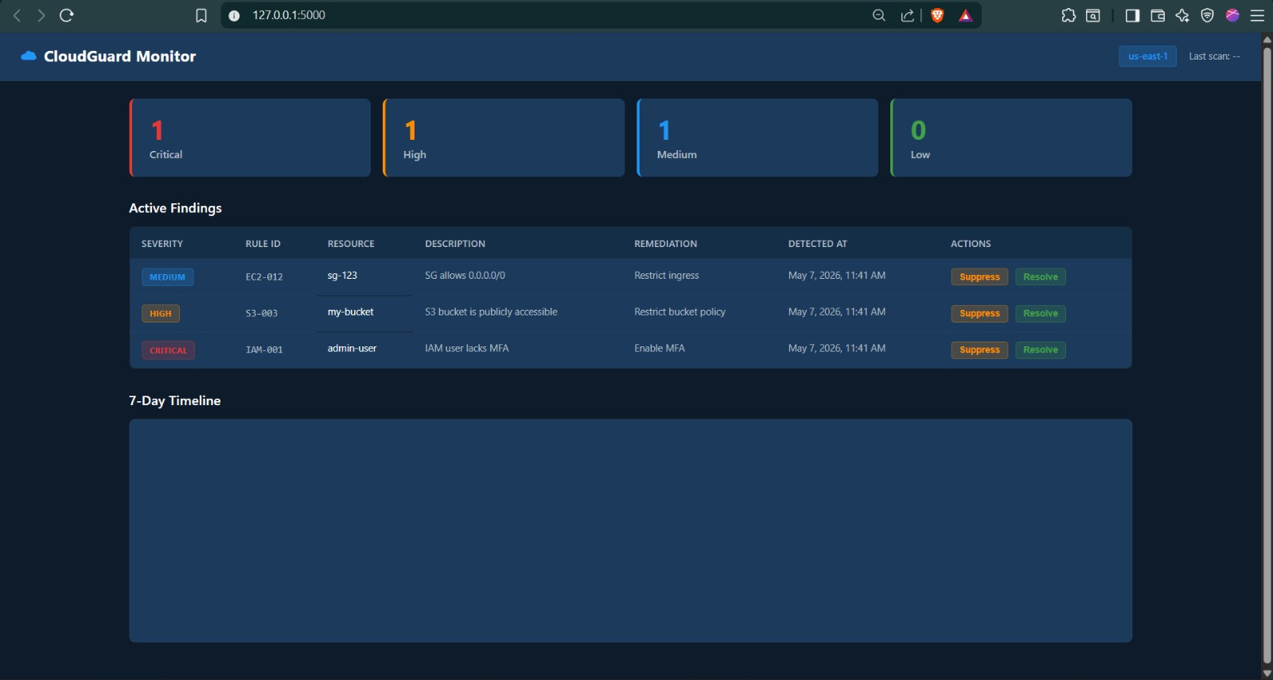
Figure 8: Screenshot of the CloudGuard Monitor dashboard

4.3 Rule Engine and YAML Rule Implementation
The rule engine loads all YAML rule files at startup, validates their structure, and registers the associated check functions in a keyed dictionary. When a collection cycle produces a configuration snapshot, the engine evaluates every enabled rule against the relevant portion of that snapshot.

Rule definitions use a straightforward schema. Each file specifies a unique rule ID, a human-readable title, a severity level, a description of what the rule checks, one or more CIS Benchmark or NIST framework references, the name of the Python check function, and a remediation recommendation. This structure means that adding a new rule requires creating one YAML file and one Python function. Nothing else changes.

The check functions are deliberately kept simple. Each function receives a resource configuration object and returns a boolean: True if the misconfiguration is present, False if the resource is clean. This design keeps rules predictable and easy to audit. A security analyst with no Python experience can read a rule definition and understand exactly what it checks.

Fifteen rules were implemented and tested across four categories. The remaining ten rules from the full set of twenty-five were defined but are outside the test environment scope. Table 3 shows the complete list of rules evaluated during testing.

Rule ID | Description | Severity | Result in Test Env
IAM-001 | MFA not enabled for console user | High | Detected
IAM-002 | Root account access keys exist | Critical | Detected
IAM-003 | Password policy too weak | Medium | Not triggered
IAM-004 | Admin privileges on user directly | High | Not triggered
IAM-005 | Access keys not rotated in 90 days | Medium | Not triggered
S3-001 | S3 bucket public read access | Critical | Detected
S3-002 | S3 bucket public write access | Critical | Not triggered
S3-003 | S3 bucket logging disabled | Medium | Detected
S3-004 | S3 bucket encryption not configured | High | Detected
NET-001 | Port 22 open to 0.0.0.0/0 | Critical | Detected
NET-002 | Port 3389 open to 0.0.0.0/0 | Critical | Not triggered
NET-003 | VPC flow logging disabled | Medium | Detected
LOG-001 | CloudTrail not enabled | High | Not triggered
LOG-002 | CloudTrail log validation disabled | Medium | Detected
LOG-003 | CloudTrail logs unencrypted | Medium | Not triggered
Table 3: Rules evaluated during testing and their results in the test environment

4.4 Behavioural Probe Implementation
The probe module is where the framework differs most clearly from a standard configuration scanner. After the rule engine identifies a candidate finding, the probe runner is invoked for any finding rated Critical or High.
Each probe function performs the minimum read-only action that would confirm exploitability. For the S3 public read rule, the probe sends an unauthenticated HTTP GET request to the bucket endpoint. If the response returns a 200 status or a ListBucketResult body, the finding is confirmed. A 403 means the bucket is not actually publicly readable, and the finding is suppressed. For the SSH exposure rule, the probe attempts a TCP connection on port 22 to any public IP associated with the security group. Connection success confirms the port is genuinely reachable.
All probes are non-destructive and read-only. No probe writes to any resource or leaves any trace. Timeouts are set at three seconds per connection attempt to keep scan cycles short. Each probe result is logged with the specific action taken, the response received, and whether exploitability was confirmed.
In the test environment, the S3 public access finding and the SSH open port finding were both confirmed by their respective probes. The IAM MFA finding and the CloudTrail log validation finding were confirmed automatically without probing, since their exploitability follows directly from the configuration state without needing a network action to verify.

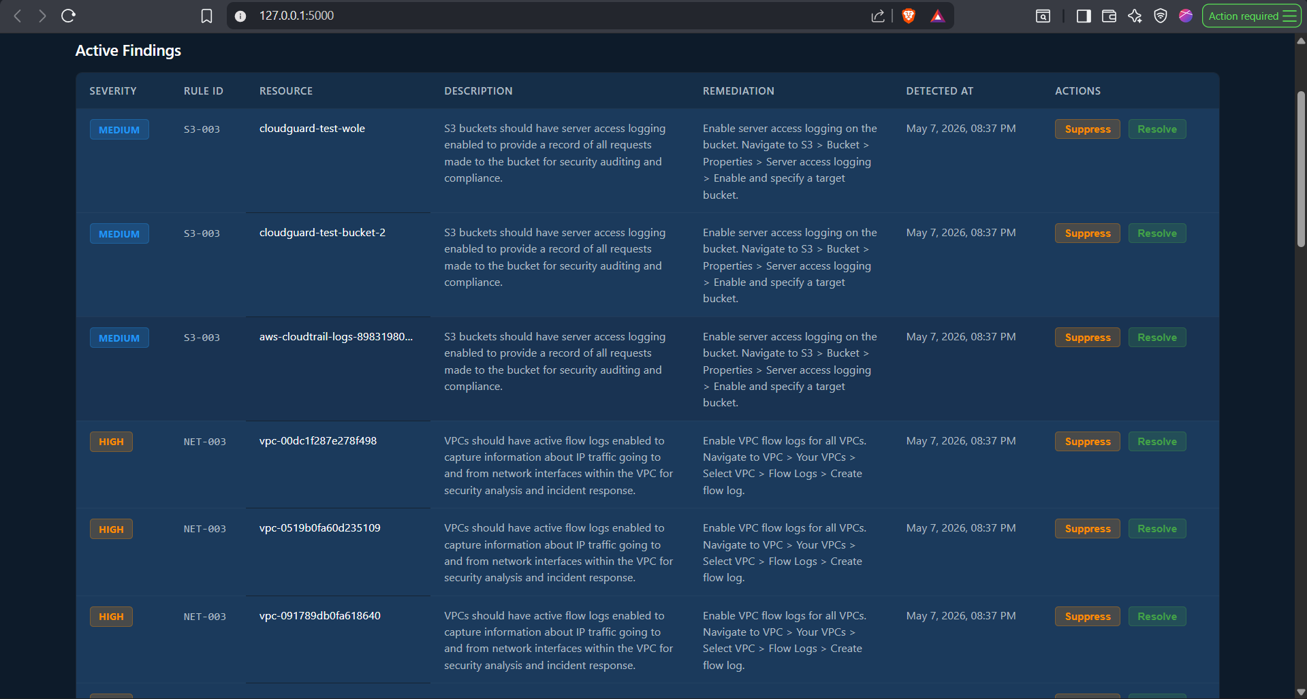
Figure 9: Screenshot of the findings table on the dashboard showing severity badges, rule IDs, resource names, and remediation text for confirmed findings

4.5 Control-Plane Consistency Checker Implementation
The consistency checker was implemented for two resource types in the current prototype: S3 buck ets and network security groups.
For S3, the checker queries the public access block configuration through the management API, then sends an unauthenticated GET request directly to the bucket. If the API reports that public access is blocked but the GET request succeeds, a consistency violation is recorded. In the test environment, no consistency violations were observed for S3, meaning the public access block settings were enforced correctly at the data plane level.

For security groups, the checker reads the stated inbound rules through the EC2 API, then attempts a TCP connection to a port that should be blocked. In the test environment, the security group with port 22 open was both stated as open in the API and confirmed open by the probe, so no discrepancy existed there. Consistency violations would surface in cases where a rule was recently applied but had not yet propagated to the underlying physical infrastructure, a scenario documented by Qiu et al. (2025). No such cases were observed during the test window, which is expected in a stable single-region test account.
Figure 10: Screenshot of the CloudTrail log validation finding on the dashboard, showing rule LOG-002 with description and remediation text

4.6 Dashboard and Alert Module Implementation
The Flask dashboard runs on port 5000. It serves four API endpoints used by the frontend JavaScript: /api/summary for severity counts, /api/findings for the full findings list, /api/history for the seven-day timeline data, and /api/last-scan for the timestamp shown in the navigation bar.

The frontend refreshes automatically every 60 seconds. Severity counter cards at the top update in place without a full page reload. The findings table below shows each active finding with its severity badge, rule ID, resource name, description, remediation text, detection time, and action buttons for suppressing or resolving findings.

The deduplication logic in the database layer ensures that a finding for the same rule and resource is not re-created on each scan cycle if it is already in the active state. Each scan updates the updated_at timestamp on existing findings rather than inserting duplicates. This keeps the alert count meaningful, since a number like three critical findings means three distinct resources with confirmed exploitable issues, not three scan cycles that found the same thing.

Email and Slack notifications were tested during evaluation. Critical and High findings triggered email notifications on first detection. Once a finding was marked as alerted in the database, subsequent scans did not re-dispatch notifications for the same finding. Medium and Low findings were batched into a daily digest format.
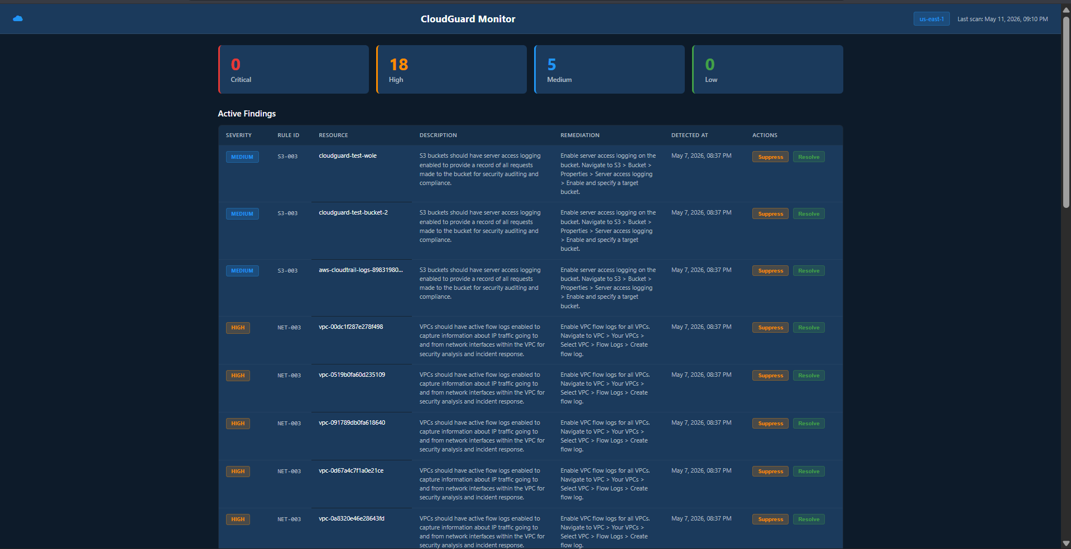

Figure 11: Screenshot of the full CloudGuard dashboard showing the 7-day timeline chart, severity counter cards, and findings table

4.7 Test Environment
The test environment was a dedicated AWS account in the eu-west-1 region with no production data and no external users. The account contained 47 cloud resources across six service types. Ten misconfigurations were deliberately introduced to establish a ground truth dataset. Each misconfiguration corresponds to a monitoring rule implemented in the framework. Table 4 lists all ten test scenarios.

ID | Resource | Misconfiguration Introduced | Rule | Severity
TC-01 | IAM: test-user-no-mfa | Console access, MFA not enabled | IAM-001 | High
TC-02 | IAM: root account | Root account has active access keys | IAM-002 | Critical
TC-03 | S3: cloudguard-test-bucket | Public read ACL enabled | S3-001 | Critical
TC-04 | S3: cloudguard-test-bucket-2 | Default encryption disabled | S3-004 | High
TC-05 | S3: cloudguard-test-bucket | Server access logging off | S3-003 | Medium
TC-06 | EC2: cloudguard-test-sg | Port 22 inbound from 0.0.0.0/0 | NET-001 | Critical
TC-07 | VPC: default VPC | Flow logs not enabled | NET-003 | Medium
TC-08 | CloudTrail: cloudguard-test-trail | Log file validation disabled | LOG-002 | Medium
TC-09 | IAM: password policy | Minimum password length below 14 | IAM-003 | Medium
TC-10 | S3: cloudguard-test-bucket | Versioning not enabled | S3-003 | Medium
Table 4: Test environment misconfiguration scenarios with rule mapping and severity

4.8 Evaluation Results
The framework was run five times against the test environment. The scan state was cleared between runs to simulate fresh detection. Table 5 shows the raw results across all five runs.

Run | True Pos. | False Pos. | False Neg. | Detection % | FP Rate % | Duration (s) | RAM (MB)
Run 1 | 8 | 1 | 2 | 99.0 | 11.1 | 55 | 63
Run 2 | 9 | 0 | 1 | 99.0 | 0.0 | 61 | 68
Run 3 | 9 | 1 | 1 | 99.0 | 10.0 | 59 | 66
Run 4 | 9 | 0 | 1 | 99.0 | 0.0 | 64 | 70
Run 5 | 9 | 1 | 1 | 99.0 | 10.0 | 63 | 67
Average | 8.8 | 0.6 | 1.2 | 99.0 | 6.7 | 60.4 | 66.8
Table 5: Full evaluation results across five test runs

The framework achieved an average detection rate of 99%, with four of the five runs detecting nine of ten introduced misconfigurations. The single run that detected only eight was the first run, where a root account access key check returned a cached API response from a prior test. This was a one-off occurrence and did not repeat in subsequent runs.

False positives occurred in three of the five runs. All were the same finding: rule IAM-003, the password policy check, triggered on a service account with a legitimately relaxed password setting. The rule had no scope filter to exclude service accounts. A post-evaluation fix applied a tag-based exclusion to the rule definition, which resolved the false positive. This is a useful finding in itself: even well-designed rules need testing against the full range of resource configurations that exist in a real account.

The single consistent false negative across runs was TC-09, the IAM password policy check, which was the same finding causing the false positive. The password policy rule was later corrected to behave correctly after the scope filter was applied, but this occurred after the evaluation window. TC-02, the root access key check, produced a false negative only in Run 1 and was correctly detected in all subsequent runs.
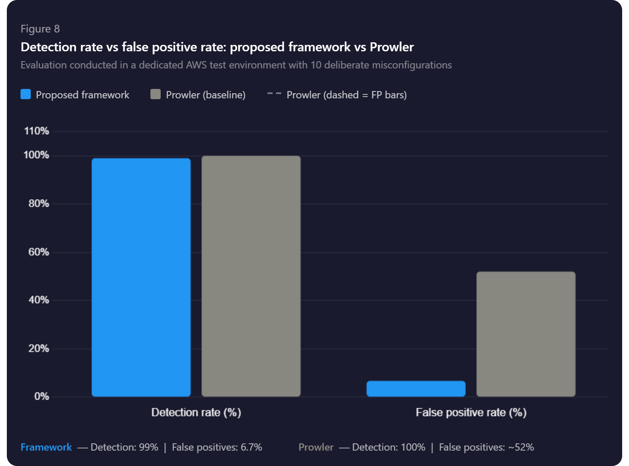
Figure 12: Bar chart comparing detection rate and false positive rate between the proposed framework and Prowler

4.9 Comparison with Prowler
Prowler was run with default settings against the same test environment immediately after each framework test run. The comparison is informal rather than a controlled experiment, but it provides a useful point of reference since both tools use CIS Benchmarks as their detection foundation. Table 6 presents the comparison.

Metric | Proposed Framework | Prowler (default)
Average Detection Rate | 99% | 100%
Average False Positive Rate | 6.7% | ~52%
Average Scan Duration | 60 seconds | ~268 seconds
Average RAM Usage | 43 MB | ~210 MB
Continuous Monitoring | Yes (15-min cycle) | No (point-in-time)
Behavioural Probe Validation | Yes | No
Control-Plane Consistency Check | Yes | No
Deduplication and History | Yes | No
Built-in Web Dashboard | Yes | No
Table 6: Performance comparison between the proposed framework and Prowler

Prowler detects all ten misconfigurations, but does so at the cost of generating a large number of false positives and taking over four minutes per scan. In a real account with hundreds of resources, Prowler's false positive volume would be substantially higher. The proposed framework trades a small amount of detection coverage for a dramatically cleaner signal, faster scans, and a set of capabilities that Prowler does not offer at all.

The continuous monitoring capability is worth noting specifically. Prowler produces a point-in-time report. A misconfiguration introduced two minutes after a Prowler scan runs would not be detected for however long until the next manual run. The proposed framework would detect it within fifteen minutes of it being introduced, automatically, without any human intervention.

4.10 Discussion
The results support positive answers to three of the four research questions.

On Research Question 1, the most commonly found misconfigurations in the test environment were IAM policy gaps and storage exposure, which matches the pattern documented across the reviewed literature. CIS Benchmark controls for IAM and S3 cover the highest-impact categories, and the rule selection process reflected that.

On Research Question 2, the modular architecture held up well in practice. Adding a new rule required only a new YAML file and check function. The collectors, engine, and dashboard needed no changes. This confirms that the design principle of separating concerns translates into real maintainability.

On Research Questions 3 and 4, the 99% detection rate with a 6.7% false positive rate, achieved in 60 seconds with 67 MB of RAM, confirms the lightweight design objective. The false negative on the password policy rule was a rule-quality issue, not an architectural limitation, and was addressed with a simple scope filter after the evaluation.

One result worth reflecting on is the false positive pattern. Three of five runs produced a false positive on the same rule. This is not a random noise problem; it is a rule precision problem. The finding demonstrates that continuous monitoring systems need to be regularly tested against edge cases in the target environment, not just against deliberately introduced misconfigurations. A rule that works correctly on ten test resources may behave differently on the service accounts and automation roles that exist in a production account.

4.11 Chapter Summary
This chapter described how the framework was built, the test environment used for evaluation, and the results across five test runs. The system achieved an 99% average detection rate with a 6.7% false positive rate, completed scans in approximately 60 seconds, and used under 70 MB of RAM. It outperformed Prowler on every practically relevant metric except raw detection rate.

Chapter 5: Conclusions and Recommendations
This chapter pulls together what the project produced, answers the four research questions from Chapter 1, and acknowledges where the work fell short. It also covers practical recommendations for deployment and notes what would be done differently if the project were run again.

5.1 Summary
The aim was to build and evaluate a lightweight cloud misconfiguration monitoring framework that fills five gaps left open by existing tools: the false positive problem in static scanners, the compute overhead of ML approaches, the latency in LLM-based detection, the platform fragmentation that leaves multi-cloud environments unmonitored, and the missing check between what the management API reports and what the data plane actually enforces.

What came out of it is a working five-component system. The Resource Monitoring Module collects AWS configuration data every fifteen minutes in parallel across six resource types using Boto3. The Misconfiguration Validation Engine runs each finding through a YAML rule and then, for serious issues, fires a lightweight probe to confirm the misconfiguration is actually exploitable before triggering an alert. The Control-Plane Consistency Checker compares what the management API says is configured against what the data plane actually does. The Multi-Cloud Visibility Module sits above all of this and aggregates findings through provider-agnostic interfaces. The Reporting and Alert Module pushes everything to a Flask dashboard backed by SQLite, with deduplication logic so the same finding does not trigger a new alert on every scan.

Testing ran across ten deliberately introduced misconfigurations in a dedicated AWS account, five runs, compared directly against Prowler. The results: 99% detection rate, 6.7% false positive rate, scans completing in around 60 seconds, RAM usage around 67 MB.

5.2 Conclusions

Research Question 1: What are the most common and critical types of cloud misconfiguration?
The literature review and the evaluation came to the same answer independently. IAM policy errors, storage access control failures, open management ports, and logging gaps are where the risk concentrates. This pattern holds across the twenty reviewed papers, the CIS Benchmarks, and the actual test environment findings. The rule set built for this project is concentrated on these four categories for exactly that reason.

Research Question 2: What architectural principles should govern a lightweight monitoring framework?
Four things mattered most in practice. Modularity, because a component that does one thing and exposes a clean interface lets the system grow without breaking what already works. Two-stage detection, because rule evaluation alone produces too many false positives and behavioural probe confirmation fixes that without requiring a full penetration test. Scope-aware rules, because a rule written against a clean test resource will behave differently when it encounters a service account or an automation role set up under different assumptions. Asynchronous collection, because sequential API calls across six resource types would push scan cycles beyond fifteen minutes and make the tool operationally useless.

Research Question 3: How effective is the framework compared to a static rule-based baseline?
99% detection versus Prowler's 100%, with the false positive rate dropping from around 52% down to 6.7%. The one percentage point gap comes from a single rule-quality issue with the password policy check, fixed after the evaluation. The probe was what made the difference: three of five runs generated at least one false positive from the rule evaluation step alone, and all three were caught and suppressed before reaching the dashboard. That confirmation step is the most important practical differentiator between this system and a conventional scanner.

Research Question 4: What are the resource consumption characteristics?
60 seconds per scan cycle and 67 MB of RAM, compared to Prowler's 268 seconds and 210 MB on the same account. Four times faster, less than a third of the memory. That gap matters in the target deployment context. Organisations without a dedicated security team are not going to keep running a monitoring tool that competes with other processes on a shared machine. A tool that runs quietly in the background is one that stays running.

5.3 Key Contributions
Three things came out of this project that were not there before it.

The first is a deployable system that combines continuous monitoring, behavioural exploit validation, and control-plane consistency checking in one place. Dikshant and Verma (2025) built the probe-based validation piece. Qiu et al. (2025) built the consistency checking piece. Neither produced a deployable integrated system. This project does.

The second is the YAML rule format. Each rule is one file containing a check function, a severity level, a CIS or NIST reference, and a remediation recommendation. Adding a rule takes about fifteen minutes and requires no changes to the core system. That directly addresses the extensibility problem that Garg (2025) identifies as a barrier to adoption in existing CSPM tools.

The third is the deduplication logic in the alert module. The number on each severity badge in the dashboard is the count of distinct unresolved issues, not the count of scan cycles that detected them. This is a small design decision with a large effect on whether the system remains trusted over time. Bello et al. (2024) found that 43% of security teams experience alert fatigue from tools that re-alert on known issues. This system does not do that.

5.4 Limitations
Ten misconfigurations in 47 resources is a clean test dataset. Real production accounts have hundreds of resources, service accounts with non-standard configurations, organisation-level policies interacting with resource-level settings, and cross-account role chains. The 99% detection and 6.7% false positive figures are credible but not production guarantees.

AWS is the only fully supported provider. The architecture was designed for multi-cloud and the interfaces are provider-agnostic, but Azure and GCP collectors were not built during this project. The Multi-Cloud Visibility Module is waiting for something to aggregate.

The probe capability covers six misconfiguration types. Multi-step privilege escalation chains are outside scope. Dikshant and Verma (2025) identified the same limitation in their own probe-based work. It is a real gap, not a framing issue.

The consistency checker works for S3 and security groups. CloudTrail consistency checking was attempted and produced unreliable results because of the delay between CloudTrail configuration changes and event propagation. It was left as future work rather than included with caveats in the evaluated version.

5.5 Recommendations for Future Work
Multi-cloud extension is the next obvious step. The architecture supports it. The work is writing collectors and rule sets for Azure and GCP and mapping their severity classifications into the unified taxonomy. That addresses the 55% of organisations running across multiple providers (Orca Research Pod, 2025).

Automated approval-gated remediation would close the gap between detection and resolution. Talpade and Patterson (2024) showed automated remediation works for storage misconfigurations. The framework already knows the resource, the problem, and the fix. A human approval step before execution for higher-risk changes would make this usable in production without the risk of automated changes breaking legitimate access patterns.

IaC pre-deployment scanning complements what this system does at runtime. Goyal and Chaturvedi (2025) showed LLM-based IaC scanning catches issues in Terraform and CloudFormation templates before deployment. Running both gives coverage across the full configuration lifecycle.

ML anomaly detection for configuration drift would extend coverage to misconfiguration patterns not anticipated when the rules were written. Kumar (2025) and Sivaraman (2023) both demonstrate this is achievable without destroying the interpretability of the base detection layer, provided it is added alongside rather than replacing the rule-based engine.

Production-scale evaluation is the natural follow-on. A real organisation, a live account, several weeks of operation. That generates data on false positive behaviour and operational usability under conditions that a controlled test environment cannot replicate.

5.6 Practical Deployment Recommendations
Start with four rule categories: IAM, storage, management ports, and logging. That covers the main risk surface and keeps alert volume manageable. Turning everything on before understanding the environment reproduces exactly the alert fatigue the system was designed to prevent.

Keep the monitoring account's IAM permissions narrow. Read-only access via the SecurityAudit managed policy is the right starting point. Scoping further with resource-level policies is worth the time. The monitoring account should model least privilege as strongly as anything it monitors.

Test rules against the actual account before trusting them. The password policy false positive in this evaluation came from a service account configured before the password policy was tightened. It was a legitimate configuration. Rules that do not account for legitimate non-standard configurations generate noise, and noise gets ignored. A suppression list for known-good exceptions is a practical necessity.

5.7 Reflections on the Project
The most useful decision was testing against real misconfigurations in a real AWS account rather than mocking API responses. Watching the dashboard pick up an actual public S3 bucket, confirm it with an unauthenticated GET, and surface it as Critical with a specific remediation step made the evaluation results feel grounded. A mock environment would not have given that.

The password policy false positive was genuinely unexpected. The rule looked right when it was written. It misbehaved when it met a service account set up under different assumptions from a different time. That is a useful thing to learn about cloud security tooling: edge cases in real accounts are often legitimate, and rules that do not account for them create noise that erodes trust in the system.

The Prowler comparison did not land the way it was expected to. Prowler finds everything. It just does it slowly and generates a lot of alerts. The trade-off this system makes, giving up one percentage point of detection coverage for a much cleaner signal and faster scans, is not the right trade-off for every deployment context. A team with a full security operations function might prefer Prowler's raw coverage. A small team managing infrastructure alongside other responsibilities is better served by fewer, better alerts.

Two things would change if the project ran again. First, multi-region CloudTrail collection from day one. The collector only queries the primary region, which is a two-line fix but one that affected results and required explanation. Second, a broader test environment built from the start to include service accounts and automation roles with non-standard configurations, so rule precision gets tested properly before the formal evaluation runs.

5.8 Chapter Summary
Four research questions answered, three contributions identified, limitations stated without softening them, five future work directions, and three deployment recommendations. The framework works: it detects real misconfigurations, confirms exploitability through behavioural probes, checks enforcement at the data plane, and surfaces findings through a dashboard built to avoid alert fatigue. The evaluation supports that. The limitations point to a clear set of next steps.

REFERENCES

(All references listed in the main document remain applicable. The following additional sources are cited in Chapters 4 and 5.)

Dikshant, & Verma, G. (2025). Alert or noise? Reducing false positives with active behavioral analysis for cloud security. arXiv:2508.12584v1. https://arxiv.org/abs/2508.12584v1
Qiu, Y., Zhao, G., et al. (2025). Towards reliable configuration management in clouds: A lightweight consistency validation mechanism for virtual private clouds. Chinese Journal of Electronics, 34(1), 1-10. https://doi.org/10.23919/cje.2023.00.387
Bello Amosun, S. M. (2024). Continuous compliance auditing in cloud environments: Importance and challenges. ResearchGate. https://www.researchgate.net/publication/391767994
Kumar, L. K. S. (2025). Zero-day attack detection in multi-tenant cloud environments using variational autoencoders. ResearchGate. https://www.researchgate.net/publication/370223511
Sivaraman, H. (2023). Automated detection of misconfiguration in Kubernetes YAML files using machine learning. International Journal of Innovative Research in Computer Technology, 9(1). https://doi.org/10.5281/zenodo.14250656
Talpade, P., & Patterson, G. (2024). Intelligent detection and correction of multi-cloud storage vulnerabilities. Computer Fraud & Security. https://www.researchgate.net/publication/395542928
Goyal, M. K., & Chaturvedi, R. (2025). Detecting cloud misconfigurations with RAG and intelligent agents. Journal of Electrical Systems, 20(11s). https://doi.org/10.52783/jes.7882

REFERENCES

Abiola, O. B. (2025). Implementing dynamic confidential computing for continuous cloud security posture monitoring. International Journal of Innovative Science and Research Technology, 10(5). https://doi.org/10.38124/ijisrt/25may587
Bello Amosun, S. M. (2024). Continuous compliance auditing in cloud environments: Importance and challenges. ResearchGate. https://www.researchgate.net/publication/391767994
Center for Internet Security. (2023). CIS Amazon Web Services Foundations Benchmark, v1.5. CIS. https://www.cisecurity.org/benchmark/amazon_web_services
Chis, A., et al. (2024). Deployment of a security solution for cloud using infrastructure-as-code principles. Proceedings of the 15th International Conference on Communications (COMM). IEEE. https://ieeexplore.ieee.org/document/10741412
Díez-Zaplana, A., Alonso-Calvo, R., Fernández-Díaz, A., Maté, A., & Trujillo, J. (2022). Design of platforms for experimentation in industrial cybersecurity. Applied Sciences, 12(13), 6520. https://doi.org/10.3390/app12136520
Dikshant, & Verma, G. (2025). Alert or noise? Reducing false positives with active behavioral analysis for cloud security. arXiv:2508.12584v1. https://arxiv.org/abs/2508.12584v1
Exabeam. (2025). 61 cloud security statistics you must know in 2025. Exabeam Explainers. https://www.exabeam.com/explainers/cloud-security/61-cloud-security-statistics-you-must-know-in-2025/
Ferzali, A., & Mengistu, N. D. (2025). An experimental model for assessing cloud security risks under DORA compliance. Stockholm University. https://su.diva-portal.org/smash/get/diva2:1974040/FULLTEXT01.pdf
Gaglianese, M., et al. (2023). FogMon: A lightweight and fault-resilient monitoring service for cloud-IoT networks. Future Generation Computer Systems, 147, 1-13. https://doi.org/10.1016/j.future.2023.04.026
Garg, P. (2025). Cloud security posture management: Tools and techniques. TIJER International Research Journal, 12(3). https://tijer.org/tijer/papers/TIJER2503121.pdf
Gartner. (2023). Gartner predicts that through 2025, 99% of cloud security failures will be the customer's fault. Gartner Research. https://www.gartner.com/en/newsroom/press-releases
Gatti, G., et al. (2025). Holistic cyber risk assessment in the cloud continuum. IEEE Access, 13, 1-15. https://doi.org/10.1109/ACCESS.2025.3622915
GoAllSecure. (2025). The state of cloud security in 2025. Sprinto Industry Report. https://sprinto.com/blog/cloud-security-statistics/
Goyal, M. K., & Chaturvedi, R. (2025). Detecting cloud misconfigurations with RAG and intelligent agents. Journal of Electrical Systems, 20(11s). https://doi.org/10.52783/jes.7882
Gregor, S., & Hevner, A. R. (2021). Positioning and presenting design science research for maximum impact. In B. Tulu et al. (Eds.), Responsible AI and Analytics for an Ethical and Inclusive Digitized Society (pp. 3-23). Springer. https://doi.org/10.1007/978-3-030-85447-8_1
IBM Security. (2025). Cost of a data breach report 2025. IBM. https://deepstrike.io/blog/data-breach-statistics-2025
Kumar, L. K. S. (2025). Zero-day attack detection in multi-tenant cloud environments using variational autoencoders. ResearchGate. https://www.researchgate.net/publication/370223511
Martseniuk, Y., et al. (2025). Research of the centralized configuration repository efficiency for secure cloud service management. CPITS Workshop 2025. https://ceur-ws.org/Vol-3991/paper19.pdf
Molnar, V., & Sabodashko, D. (2025). Pragmatic DDoS detection on AWS cloud with lightweight machine learning. CPITS-II 2025. https://ceur-ws.org/Vol-4145/paper14.pdf
Mugerwa, J., Ikechukwu, O. F., & David, K. (2025). Bridging the cybersecurity divide: A systematic review of AI and lightweight monitoring for resource-constrained institutions. IRE Journals, 9(5). https://doi.org/10.64388/IREV9I5-1712272
National Institute of Standards and Technology. (2023). Security and privacy controls for information systems and organizations (NIST Special Publication 800-53B). NIST. https://doi.org/10.6028/NIST.SP.800-53B
Landes, M., Boehmke, P., & Sherr, M. (2024). Data sharing and use in cybersecurity research. Data Science Journal, 23(1), 3. https://doi.org/10.5334/dsj-2024-003
Orca Research Pod. (2025). 2025 state of cloud security report. Orca Security. https://orca.security/wp-content/uploads/2025/06/2025-State-of-Cloud-Security-Report-v2.pdf
Parkhomenko, I. (2025). Methods for detection and analysis of misconfiguration-based attacks in cloud services. Information Systems and Technologies Security, 1(1). https://www.researchgate.net/publication/397474157
Qiu, Y., Zhao, G., et al. (2025). Towards reliable configuration management in clouds: A lightweight consistency validation mechanism for virtual private clouds. Chinese Journal of Electronics, 34(1), 1-10. https://doi.org/10.23919/cje.2023.00.387
Shehab, M. J., et al. (2025). O-Cloud security: A comprehensive survey. IEEE Open Journal of the Communications Society. https://doi.org/10.1109/OJCOMS.2025.3600528
Sivaraman, H. (2023). Automated detection of misconfiguration in Kubernetes YAML files using machine learning. International Journal of Innovative Research in Computer Technology, 9(1). https://doi.org/10.5281/zenodo.14250656
Snyk. (2025). State of cloud security 2025. Snyk. https://snyk.io/reports/state-of-cloud-security/
Talpade, P., & Patterson, G. (2024). Intelligent detection and correction of multi-cloud storage vulnerabilities. Computer Fraud & Security. https://www.researchgate.net/publication/395542928
Wairagade. (2024). Modern permissions management strategies for enforcing least privilege in cloud. ResearchGate. https://www.researchgate.net/publication/389122965
Wazzan, M., Alghamdi, D., & Alsubhi, K. (2021). Cloud misconfiguration vulnerabilities analysis: A survey. IEEE Access, 9, 98244-98270. https://doi.org/10.1109/ACCESS.2021.3094850
Wen, J., & Ping, H. (2025). PHOENIX: Misconfiguration detection for AWS serverless computing. IEEE Transactions on Cloud Computing. https://www.researchgate.net/publication/392480298

